SPM Trust ®

Paramahamsa Yoga Mahavidyalaya

(For Yoga Spiritual, cultural, education & Research Center with a difference)

**Guidance:**

1. Yogacharya, Yoga Prarena Sree Shivaprakash Guruji Chairman
2. YogaRathna Dr|| Bhavana Mahdhushudhan BAMS. MS
3. Smt Poornima Sandeep B.E
4. Dr.Krupa Rao BNYS MD in Yoga

Sit in your comfortable position, (Vajrasana, Padmasana, Sukhasana, Siddasana, Swastikasana) with back neck head straight in one line.

Close your eyes, visualise your parents, family diety, individual diety, gurus and elders in the live form and chant the following mantras three times.

### **Shatkriya**

Shat Karma, or Shat Kriya as they are often known, are six yogic cleansing processes used by yoga practitioners to help purify the physical body.

The body has an incredible natural tendency towards homeostasis i.e. the body will always try to heal itself and achieve good health even when we treat it badly. Cut yourself and the body will repair the damage. Eat unhealthy food and the body will still keep going. In yoga we try to protect ourselves from injury and attempt to avoid harming ourselves by overindulging in unhealthy foods. This is part of the practice of ahimsa – avoiding harmful or injuring behaviour either towards oneself or any other beings.

Despite all our best intentions and efforts our body sometimes needs a little extra boost to reach a state of optimum health. With the rise of industrialization, mass urbanization and financially driven agriculture, the air we breathe, the food available, even the water we drink may not be as pure and unpolluted as we would wish them to be. The Shat Kriyas come to our aid to help us remove built up toxins from our body, with particular emphasis on the respiratory and digestive systems.

Shat is the Sanskrit word for six, however each of the six kriyas may involve several different cleansing techniques or practices.

**The six Kriyas are:**

1. Neti

2. Dhauti

3. Nauli

4. Basti

5. Kapalabhati

6. Tratak

1 - Neti kriya has two component practices named *Jala neti & Sutra neti*.

*Jala neti* involves the use of a neti pot or lota. The neti pot is filled with warm salty water and the contents of the pot are poured into one nostril and allowed to flow out of the opposite nostril. This helps cleanse the nasal passages of particles of dust or pollution and stimulates the mucous glands.

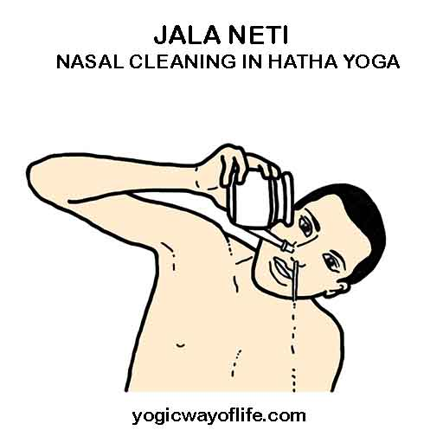

*Sutra neti* is done by inserting a string in one of the nostrils and gently pushing that string through the nasal passage and letting it come down to the back of the throat. Then the string is grasped between two fingers and drawn out of the mouth. The ends of the string can be attached together and the circle thus formed is drawn through the nostrils several times. This practice strongly stimulates the mucous glands and also activates the tear ducts which in turn naturally cleanse the eyes. Traditionally a thin string with waxed ends is used though nowadays it is common to use a rubber surgical catheter.

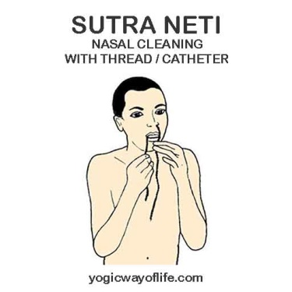

2 - Dhauti kriya can be divided into five different practices: Kunjal kriya, vastra dhauti, danta dhauti, vatsara dhauti and agni sara all of which are best practiced on an empty stomach.

Kunjal Kriya, also known as vaman dhauti, cleanses the upper digestive tract of excess mucous. The practitioner drinks a large quantity of warm salty water and then vomits. The vomiting can either be induced by vigourously rubbing the back of the tongue or may occur spontaneously.

The food one chooses to eat after this practice is very important as the lining of the digestive tract needs to be re-established. Traditionally kedgeree, a mixture of rice and moong dal, is eaten within the hour after practicing kunjal kriya.

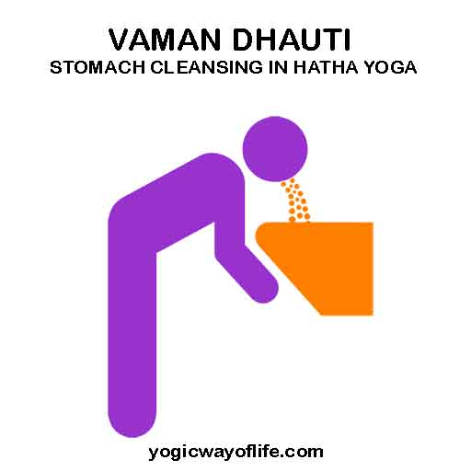

Vastra dhauti is done by swallowing a long thin strip of cloth. The cloth can be up to 3 metres long and needs to be soaked in salty water first. This rather intense practice removes excess mucous from the digestive tract.

Vastra dhauti involves swallowing air and belching (or alternatively letting the air pass through the lower intestine). The digestive system is stimulated and excess gas is removed.

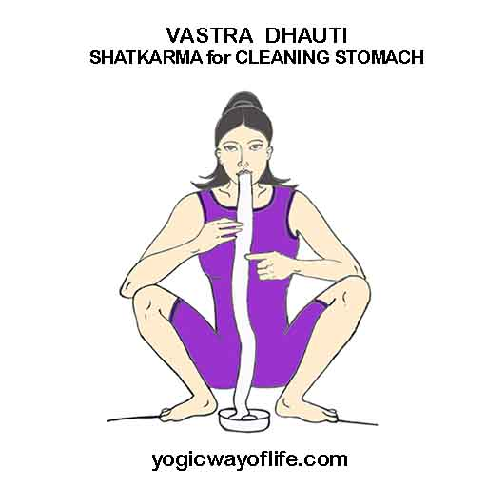

Agni Sara is performed by exhaling while leaning forward and then holding the breath while pumping the abdomen. It helps to improve digestion and strengthens the abdominal region. Practicing regularly will improve over all energy levels and remove lethargy.

3 - Nauli is a technique whereby the abdominal muscles are contracted in a specific manner and moved about in order to massage the digestive tract.

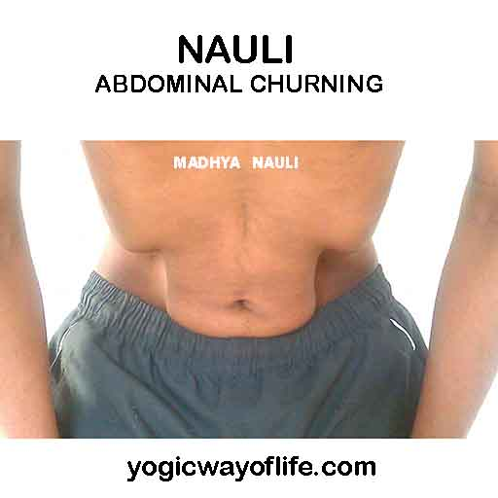

4 - Basti is essentially the same as an enema and is used to cleanse the lower digestive tract. Water is taken in to the lower digestive tract via the anus and then expelled. Traditionally yogis practiced this by standing in a fast flowing river and using a hollow reed to take in the water.

5 - Kapalabhati is often considered as a Pranayama breathing technique, but it is also an important kriya. The breath is expelled through the nose by a strong contraction of the abdominal muscles. Then the abdomen is relaxed completely which automatically lowers the position of the diaphragm creating a passive inhalation. The abdomen is contracted and relaxed in this way for a series of pumpings. The air sharply expelled helps to remove dust particles from the respiratory tract and strengthens the lungs. The increase in air inhaled raises the oxygen levels in the blood stream and helps regulate the metabolic rate. Kapalabhati is useful to practice before meditation as it induces a calm state of mind.

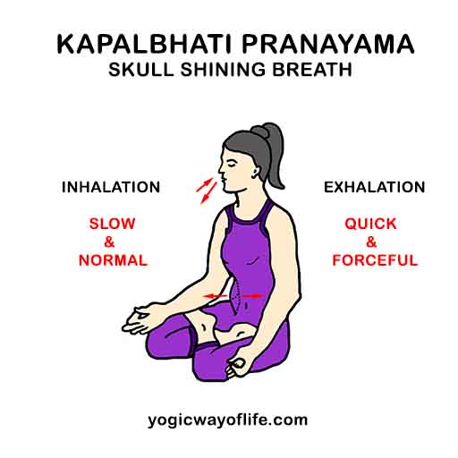

6 - Tratak cleanses the eyes and is used as an approach to meditation. Sitting comfortably you stare at the wick of a lit candle for a minute or so. Then close the eyes and observe the afterimage left on the retina. Try to keep this image of the flame steady by keeping the eyes very calm.

The candle flame should be at eye level and about arms length away from the eyes. When the after image fades the eyes can be covered with the hands and the image may be rediscovered. Then the practice is repeated. This deceptively simple exercise affects the mind on many levels and is excellent for improving concentration, alleviating sleep disorders and quietening the mind, which is after all the definition Patanjali gave us.

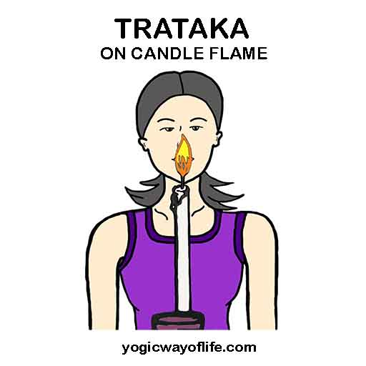

**Prayer**

**I Seal Mantra:**

Om Shiva, Om Shiva, Om Shiva Breathe in Breathe out chanting 50% Omkara K 50% Shiva.

**II Shiva Mantra ( 3 times)**

Om Yoga Yoga Yogeshwaraya

Bhutha Bhutha Bhutheshwaraya

Kaala Kaala Kaaleshwaraya

Shiva Shiva Sarveshwaraya

Shambho Shambho Mahadevaaya

**III Mahavidyalaya Prayer**

Om Bhramha-Rupaam adimadhya Shesha Sarva Bhasakam

Bhava Shakta Heena Ripa Nitya Sathya Madhvayam

Vagmanotha Gocharancha Neti Neti Bhavitham

Tam Namami Deva Deva Rama Krishnanishvaram (2)

**IV Guru Mantra**

Om Guru Brahma Gurur Vishnu

Gurur Deva Maheshwaraha

Guru Saakshaath Parabrahma

Tasmai Sree Guruva Namaha

Om Shanthi Shanthi Shanthih

**V. Shanthi Mantra**

Om Shanavavatu

Saha Veeryam Karavaavahai

Tejasvi Naanadhedamastu Maa

Vidvishaavahai

Om Shanthi Shanthi Santhih ||

**VI Gratitude:**

Om Matrudevo Bhava

Om Pitru Devo Bhava

Om Kutumba devo Bhava

Om Ista devo Bhava

Om Acharaya devo Bhava

Om athithi devo Bhava

Om Rastra devo Bhava

Om Vishwa devo Bhava

Om Sarva Jana Sukhino Bhavanthi

Om Sarva Jeeva Sukhino Bhavanthi

Om Shanthi Shanthi Shanthi

Sree Gurudev

**VII Seed Mantra (end chanting)**

Adopt namaskara mandra, place your both the thumbs inbetween your eyebrows (ajna chakra) and chant

Shiva Om, Shiva Om, Shiva Om, Breathe in, Breathe Out chant 50% Shiva & 50% Omkara.

With the same position, breathe in and Surrender to mother earth while breathing out. Touch your forehead to mother earth.

Breathe in come up, Rub your both the palms, bring your palms infront of your chest, open your palms and look at your palms with a bigh smile.

**Benefits of clapping**

“Clap your hand, make your disease runaway”

**Clapping can**

Overcome heart diseases & Blood persons

Asthma & diabeties

Activates & loosers name

make us very relaxed

strengthens the WBC

Improves the skills in children

improves the intellechuals in children

blood circulation improves

improves the activities of arteries and ventricles

Removes bad cholestrol, laziness,

Removes depression, cold & joint pains

Make yourseld fill by clapping 1500 items daily.

Balances the breathing

Improves the handwriting & spelling mistakes

clapping after meals improves digestion

apply mustard oil or coconut oil to the palms before clapping, it will asimilate into the body.

Improves hair growth, controls hair fall. Also overcomes insommiar

**Brain activation**

By clapping all the name endings in the palm gets activated, and to reflexes the brain gets activated, inturn whole body gets activated. It gives different feel to our physical body.

**Clapping works as accupressure.**

Clapping with chanting removes the negative energies and all the abstacles our desires will be fulfilled.

Chant: Om Shiva - Om Shiva - Shiva Shiva Ommm

Clapping \_ chanting + leg movements, we will receive the grace of adi yogi” lord shiva, we can over come all our negative attitudes and obstacles. we will be blessed with good health and prosperity.

**Practice of clapping**

Type 1- Leg movements

Type 2 - Two palm in namaskara mudra

**JOINT EXCERCISE (With pranayama)**

can be done 3 hrs after a meal, 2 hrs after a breakfast or 1 hr after coffee/tea/milk

Drink a cup of water (normal / take warm) before doing this practice

It activates all the muscles, blood circulation, blood vesels, lungs, all veins, joints, all glands, and improves the immunity rib cage expands. joints of hand & shoulders get relaxed lings & diaphragm expands lower back gets relaxed calf muscles & thigh muscles expands. Pain in the joints of nerce and vein relaxes. Sinoual fluid helps in production of sinormal fluid reduced the carbon di oxide in the lungs improves digestion, burns excess overcomes indigestion, gastric trouble, feels light physically, blood circulation to brain strengthen the navel muscles, removes breathing imbalance. Practicing joint excercise with pranayama helps all the organs to get good +ve energy improve the stability of the mind & concentration. the beauty of this excercises is it includes all the organs & joints mind becomes peaceful & helps in meditation.

**Breathing Technique**

1. I - Inhale / Breathe in

2. IH - Inhale hold / Breathe in hold

3. E - Exhale / Breathe out

4. EL - Exhale low/ Breathe out lock

Stretch your hands paralalel to ground, palms facing each other.

Inhale Handsup & Exhale Handsdown

**Similarly**

1. I - make a fist in both hands, thumb out

2. fist making fist thumb inside

**4. Excencer**

1. Make fist in both hands, thumb outside fist facing the sky

inhale - flex the wrist & hold, Exhale - extend the wrist & lock

2. Now fist facing the ground

Inhale- flex the wrist & hold, Exhale- Extension & lock

3. Now fist facing each other

4. lastly rotation of wrist normal breathing

**Elbow**

Fist Inside - ihale flex & exhale extension

Fist facing outside

**Arms**

Interlock yours fingers in front of chest

1. hands parallel to ground

Inhale stretch – hold, Exhale fold - lock

2. hands 45 to ground

3. hands 90 to ground

**Stretch your hands in front of the chest facing each other**

hands stretch, Inhale out - hold, Exhale front - lock

**Hand beside your thighs**

Inhale hands by the side up - hold

Exhale, hands by the side down - lock

**Neck excercise:**

Inhale up & hold Exhale front & lock

Inhale right & hold Exhale front & lock

Inhale left & hold Exhale front & lock

Inhale right side & hold Exhale front & lock

Inhale left side & hold Exhale front & lock

Exhale down & lock Inhale front & hold

**Back Excercise:**

Inhale both hands by the side up bend backward & hold exhale come up lock

**Lateral stretch**

Inhale right hand by the sideup & holdl

Exhale hands down and lock same on left side

**Upper body twist:**

Stretch hands, palm facing each other

Inhale thrist to right and hold

Exhale untrist to front & lock

same on left side

**Front Bending:**

stretch hands above the head, palm facing each other

Exhale bend forward & hold lock

Inhale comeup & hold

**Hip rotation:**

Hands on your waist, start with bending position

Inhale up & hold, Exhale down & lock

**SURYA NAMASKARA**

Surya Namaskara or the Sun Salutation has a great energizing effect on the body, prana and mind. In Sanskrit, ‘Surya’ means the sun and ‘Namaskara’ means the salutation. Surya Namaskara consists of a series of yoga postures. There are 12 yoga poses performed in sequence. Surya Namskara is usually done in the morning during sunrise, facing the rising sun. It may also be done during sunset, again facing the setting sun.

Surya Namaskara can be performed at various speeds. A slow rhythmic practice is recommended as it has greater effect on the mind. Surya Namaskara helps to attain a meditative mood when performed slowly, with attention on the breath and chanting the specific mantra. When performed with speed, it has more effect on the body, energizing it and burning extra calories. No matter what the speed is, one has to perform the 12 poses with breath awareness. The 12 poses and the associated mantras should be learnt from an experienced yoga instructor.

Surya Namaskara should not be practiced by those suffering from high blood pressure, coronary diseases and strokes. Also those with hernia should avoid this. Women should generally not practice it during pregnancy. People with spondylitis and sciatica should consult a doctor before practising Surya Namaskara.

**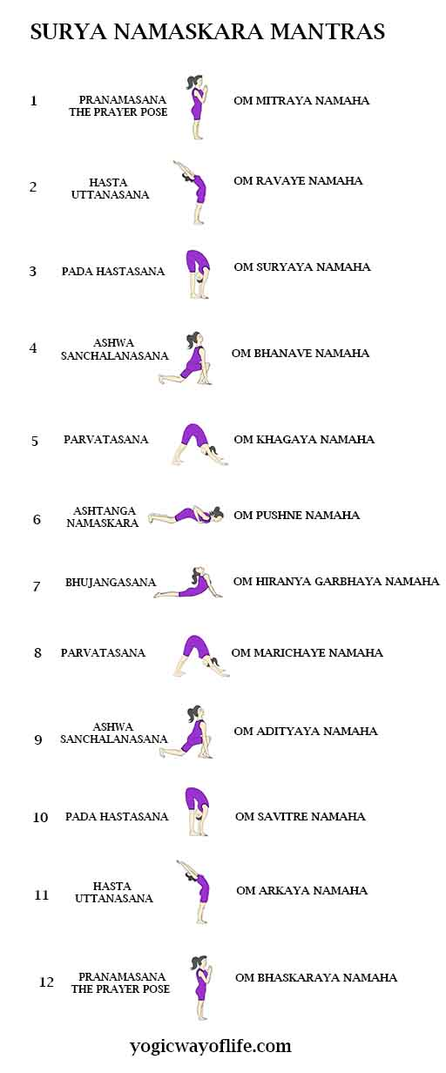**

**Surya namaskara-A**

**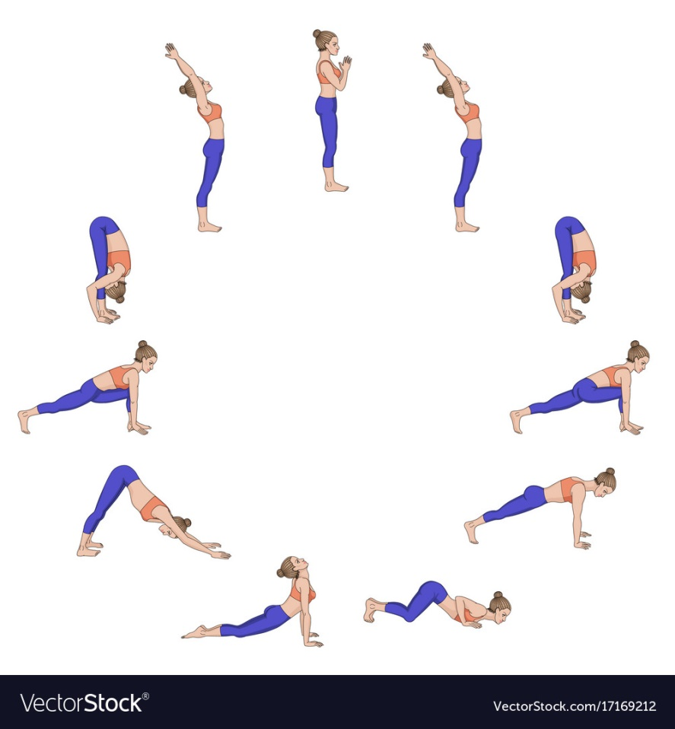**

**Surya namaskara-B**

**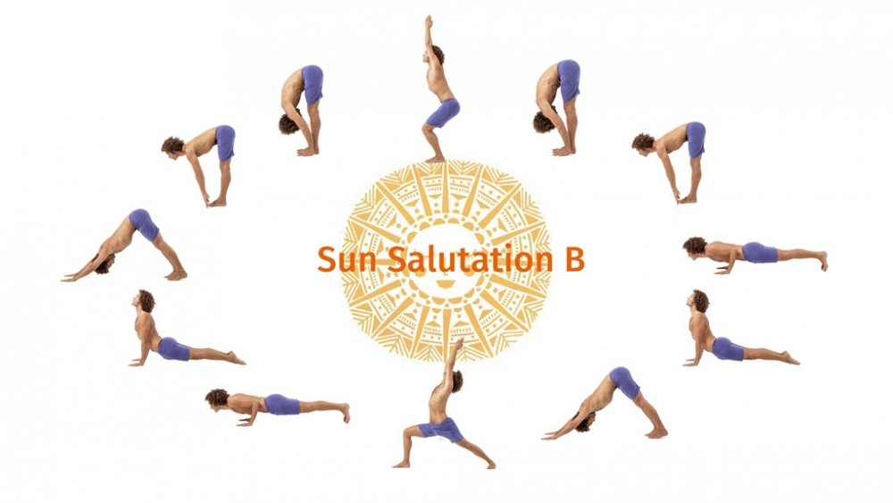**

**ASANAS(D¸À£ÀUÀ¼ÀÄ)**

**Standing Asanas:**

1. **Parvatasana**

Stimulate your obdominal organs & your lungs

**Benefits :-**

* Strengthens nerves and muscles in the arms and legs.
* The spinal nerves and toned and circulatio is stimulated especially in the upper spine, between the shoulder blades.
* Stretches the shoulder muscles and increases the breathing capacity of lungs.
* Helpful in treating respiratory disorders such as Asthma.

**Modifications :-**

Beginners can take the support of wall to lean.

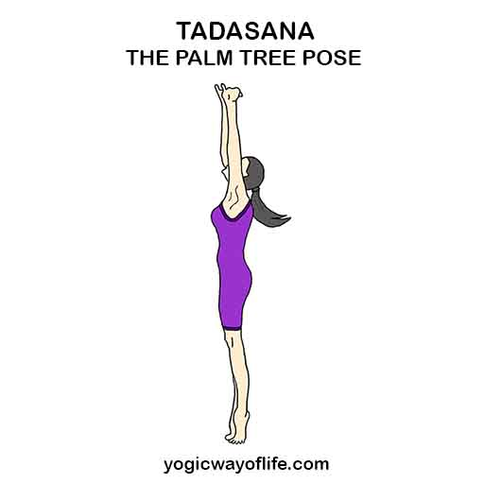

1. **Vrikasasana**

**Benefits :-**

* Improves balance and stability in the legs.
* Strengthens the ligaments and tendon of the feet.
* Strengthens your knees, ankles and overall leg strong and flexible.
* Tones the legs, open the hips.
* Develops neuromuscularcoordination and improves conecetration.

**Modifications:-**

* In case of high blood pressure, you should not raise your arms overhead.
* Instead of can place them near your chest.
* Obese people can place the foot just above the knee for better comfort ability.

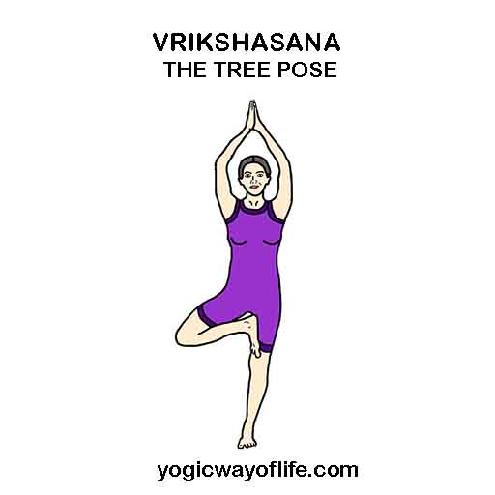

1. **Garudasana**

**Benefits:-**

* Improve balance
* Stretches upper back, shoulders and outer thighs.
* Opens back of pelvis, creates space between shoulder blades.
* Makes legs, knees and ankles strong.

**Limitations:-**

If you are suffering from knee injury or joint - pain, then you must not practice this asana.

**Modifications :-**

If you have shoulder or arm problems, keep your arms in the prayer pose.

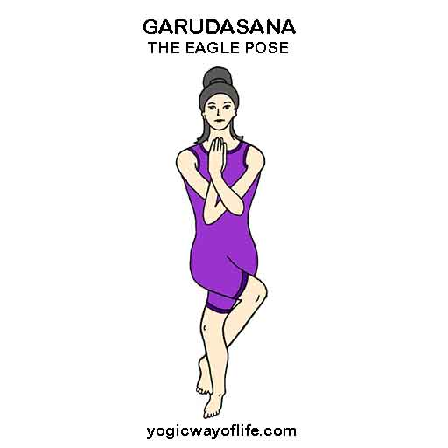

1. **Utkatasana**

**Benefits:-**

* This pose increases strength, balance and stability.
* Strengthens the spine, calves, thinghs and ankles.
* Stretches the chest and shoulders.
* Stimulates the heart, diaphragm and abdominal organs.
* Helps reduce fat in the body, especially in the buttocks.
* Helpful in conditions like arthritis and joint pain.
* Improves functioning of the immune system.

**Limitations:-**

* Low Back Pain–Only go as deep into the pose as you can while still maintaining your natural lumbar curve.

**Modifications:-**

* If you find difficult to keep your heels rooted firmly to the ground roll or fold your mat a little until you can get your entire foot to touch the ground.

**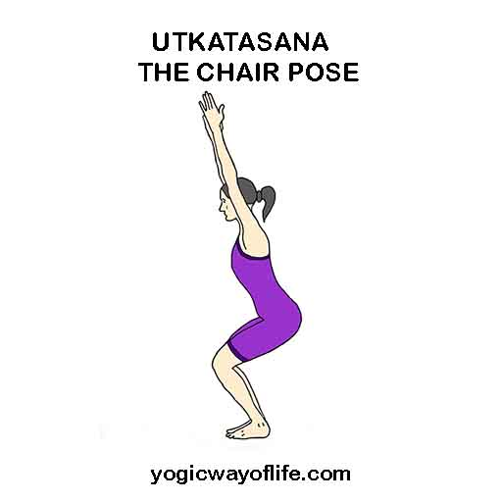**

1. **Triyakatadasana**

**Benefits:-**

* This asana develops a sense of balance.
* The whole body is stretched which loosens up the entire spinal column from top to bottom.
* The abdominal organs and muscles are toned up.
* Improves control over body balance. Spondylitis or inflammation of the vertebral joints greatly benefits forms this effect.
* This asana helps to release trapped gas from the colon by alternately creating pressure and expansion of the abdomen used in shankaprakshalana kriya.

**Modifications:-**

* People with ankle injury can place a double cushioned mat and try only as much possible.

**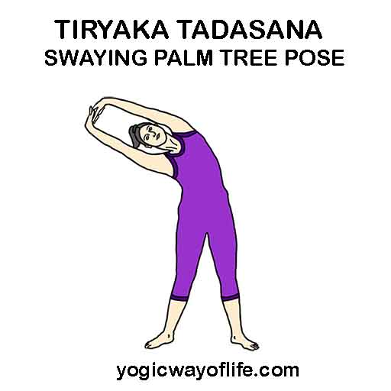**

1. **Ardha kati chakrasana**

**Benefits:-**

* Makes the spine flexible, stimulates spinal nerves, and promotes circulation of blood into head.
* Strengthens the neck muscles.
* Expands chest, shoulders and improves breathing.

**Limitations:-**

* Persons with problems of vertigo (Dizziness)have to avoid this posture.

**Modifications:-**

* Beginners can practice this close to a wall for safety

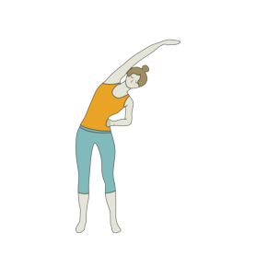

1. **Kati chakrasana**

**Benefits:-**

* It gives a nice stretch to the waist and makes the spine more flexible and supple.
* Good for relieving constipation. Good for arm and leg muscles.
* Opens up the neck and shoulders and strengthens the abdominal muscles and lower back.
* Beneficial for those with sedentary or deskbound job.

**Limitations:-**

* Avoid practicing standing Spinal Twist (Katichakrasana during pregnancy, or if you have hernia, slip disc, or have had an abdominal surgery recently.

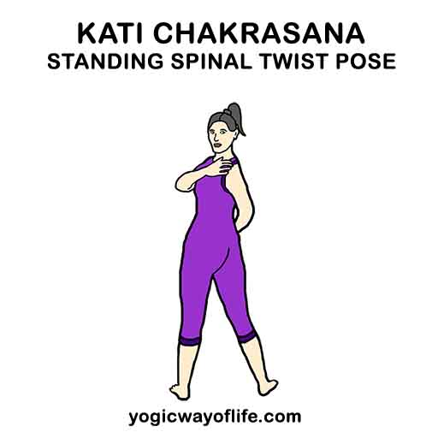

1. **Ardha chakrasana**

**Benefits:-**

* Makes the spine flexible, stimulates spinal nerves, and promotes circulation of blood into head.
* Strengthens the neck muscles.
* Expands chest, shoulders and improves breathing.

**Limitations:-**

* Persons with problems of vertigo(Dizziness) have to avoid this posture

**Modifications:-**

* Beginners can practice this close to a wall for safety.

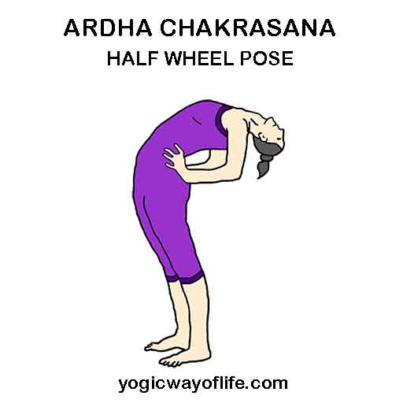

1. **Padangustasana**

**Benefits:-**

* Stretching in this pose increases the blood flow to the brain.
* Iimprovs the concentration and retention power.
* Calms the brain and helps relieve stress, anxiety and migraines.
* Stimulates the liver and kidneys.
* Stretches the hamstrings and calves.
* Strengthens the thighs.
* Improves digestion. Helps relieve the symptoms of menopause.

**Limitations:-**

* Severe back pain, Hernia patients can avoid this posture.

**Modifications:-**

* Beginners can bend the knees slightly.

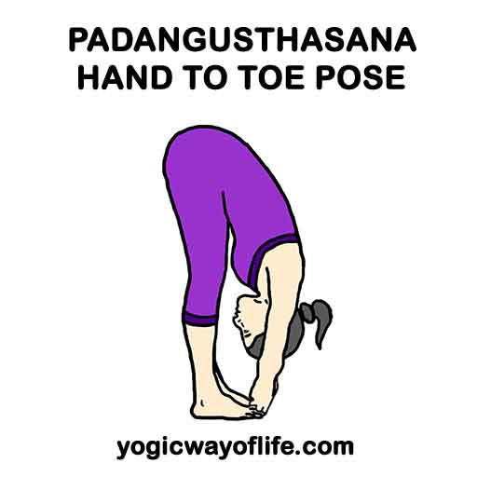

1. **Padahasthasana**

**Benefits:-**

* Makes the spine flexible, Strengthens thighs & knees
* Helps in preventing constipation and menstrual Problems.
* Improves digestion, enhances blood flow to head.
* Reduces fatigue and anxiety.
* Relieves headache and insomania.
* Therapeutic for asthma, high blood pressure, infertility, osteoporosis, and sinusitis.

**Limitations:-**

* People with Vertigo Cervical spondylitis and disc prolapse to avoid this posture.

**Modifications:-**

* If you're not palms are not able to reach the floor, bend only as much as possible.

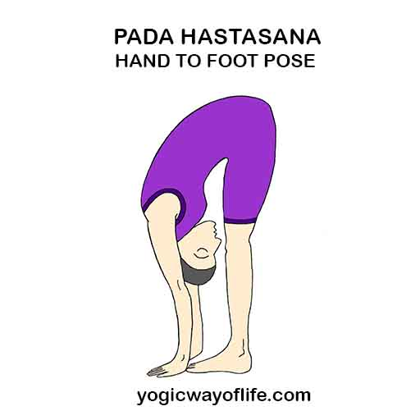

1. **Parshvothanasana**

**Benefits:-**

* Stretches shoulders, waist & hamstrings, hips, Chest and Spine.
* Builds balance & Flexibility.
* Improves Postural habits, Digestion.

**Limitations:-**

Chronic Injury to the hips, back or shoulders, do not practice this asana.

People suffering with abdominal hernia or heart problem people avoid this asana.

**Modifications:-**

* hold your ankle or shinbone and bend only as much possible.

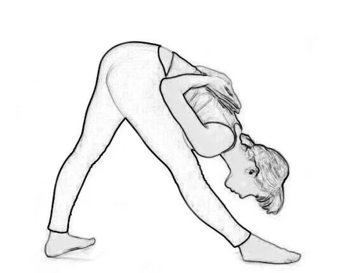

1. **Prasaritha padothanasana**

**Benefits:-**

* Stretches the hamstring and abductor muscles.
* Opens the hips, Strectches the spine, shoulders and chest.
* Grounds you and calms the mind.
* Can relieve mild backache.
* People who cannot do Sirsasana can benefit from this pose, which increases digestive powers.

**Limitations:-**

* People with Vertigo, lower back injury can avoid this posture.

**Modifications:-**

* Place your hands on the wall at hip height, shloulder- width apart.

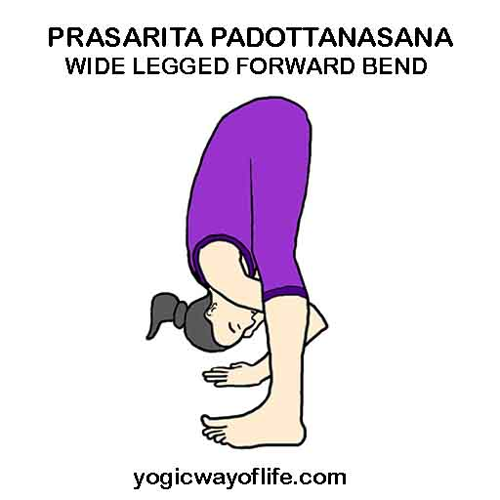

1. **Trikonasana**

**Benefits:-**

* Stretches and strengthens the thighs, knees, ankles, hips, groins, hamstrings, calves, shoulders, chest, and spine.
* Stimulates the abdominal organs.
* Helps to relieve stress.
* Improves digestive power.
* Helps to relieve the of menopause.
* Relieves backache, especially through second trimester of pregnancy.
* Therapeutic for anziety, flat feet, infertility, neck pain, osteoporosis and sciatica.

**Limitations:-**

* People who have undergone recent abdominal suregery, slip disc, or sciatica may avoid this asana.

**Modifications:-**

* High blood pressure peoplet turn the head to gaze downward in the final pose.
* Neck problems people don't turn your head to look upward, continue looking straight ahead and keep both sides of the neck evenly long.

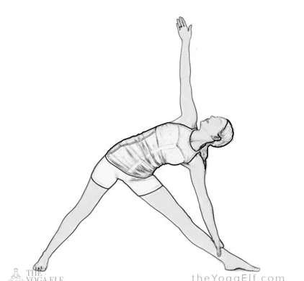

1. **Parivritta trikonasana**

**Benefits:-**

* Gives rottional movements to the spine.
* Improve functioning of kidneys and strengthens the thigh muscles.
* Strengthens and stretches the legs.
* Opens the chest to improve breathing. Relieves mild back pain.
* Stimulates the abdominal organs Improves sense of balance.

**Limitations:-**

* People with spinal problems, heart problems, severe hypertension may avoid this.

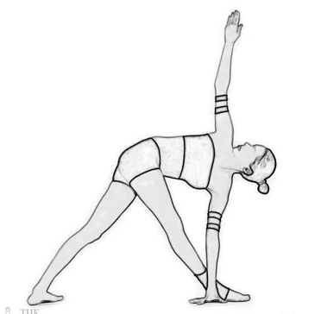

1. **Veerabhadrasana-1**

**Benefits:-**

• Stretches the chest and lungs, shoulders and neck, belly groins(Psoas).

• Strengthens the shoulders and arms, and the muscles of the back.

• Strengthens and stretches the thighs, calves, and ankles.

Limitations:-

• Knee arthritis, hip injury people to avoid this asana.

**Modifications:-**

• If you have any neck problems, don't turn your head to look upward, look forward.

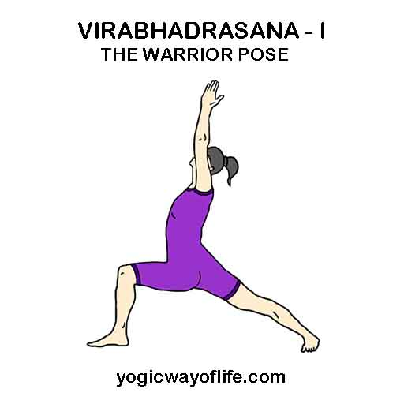

1. **Veerabhadrasana - 2**

**Benefits:-**

• Strengthens and stretches the legs ovel ankles.

• Strengtches the grains, chest and lungs, shoulders.

• Increases stamina.

• Relieves backaches, especially through second trimester of pregnancy.

• The rapeutic for carpal tunnel syndrome, flat feet, infertility, osteoporosis and sciatica.

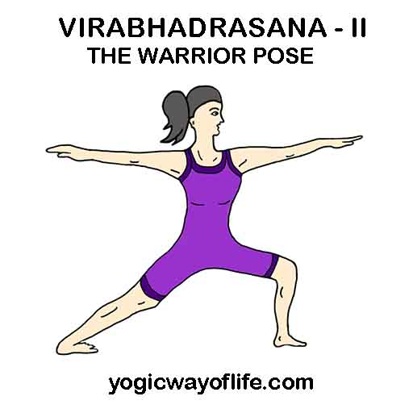

1. **Veerabhadrasana - 3**

**Benefits:-**

• Strengthens the legs, ankles, shoulders and back.

• Tones the entire body, especially your abdomen.

• Improves memory and concentration.

• Encourages better posture and better.

• Invigorates and energizes.

**Limitations:-**

• Knee Arthritis

• Vertigo people to avoid this asana.

**Modifications:-**

• Stretching your arms out to the sides at shoulder level. This variation is called "Airplane Pose".

• Beginners can take the wall support initially.

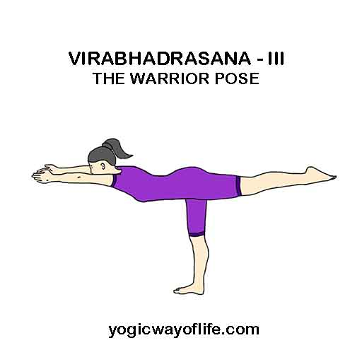

1. **Utthitha Hastha Padangusthasana - 2**

**Benefits:-**

• Stretches hamstrings and hips.

• Stretches adductors.

• Strengthens back and arm muscles.

• Improves sense of balance.

• Calms the mind and improves focus.

**Limitations:-**

• Ankle injuries.

• Lower back injuries.

• Tight hamstrings.

**Modifications:-**

• For help with balance, try this pose with your free hand against a wall.

• For tight hamstrings, keep the knee on your extended leg bent or warp a strap around your foot and take hold of the strap.

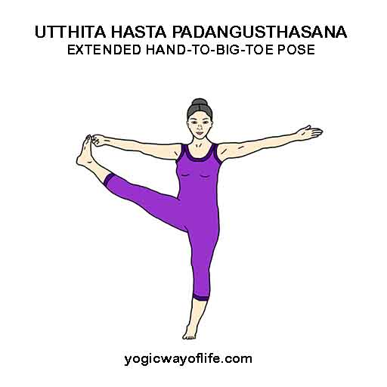

1. **Natarajasana**

**Benefits:-**

• Develops concentration and balance.

• Tones and stretches the leg and hip muscles.

• Stretches the hip fiexors.

• Strengthens the arch in the standing foot.

• Develops range for motion in the shoulders.

• Expands the chest and front body.

• Strengthens the back body in a back bend.

**Limitations:-**

• Slipped disc.

• Arthritis.

• Shoulder injuries.

• Low blood pressure.

**Modifications:-**

• If your can't grab hold of your back foot, wrap a strap around your foot and hold the strap instead.

• If you are struggling with balance, use a wall support for balance.

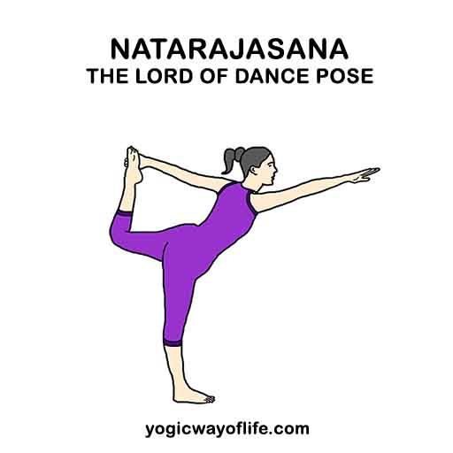

1. **Anjaneyasana**

**Benefits:-**

• Opens the groin and hips.

• Stretching of the quadripceps, hamstrings and groin and Kneepads.

• Relieves knee pain, shoulder or back pain, and even abdominal pain.

• Furthermore, it stimulates your reprouctive organs as well.

• It helps to build mental focus.

• Improves Flexbility.

**Limitations:-**

• Not for people suffering from heart problems, hernia or lower back pain.

**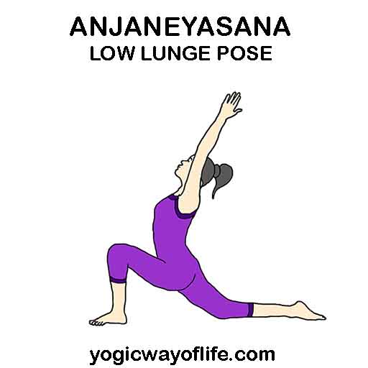**

1. **Ardha Chandrasana**

**Benefits:-**

• Strangthens the abdomen, ankles, thighs, buttocks, and spine.

• Stretches the groins, hamstrings and calves, shoulders, chest, and spine.

• Improves coordination and sense of balance.

• Helps relieve strees.

• Improves digestion.

**Limitations:-**

• Headache or migraine.

• Low blood pressure.

• Diarrhea.

• Insomnia to avoid this assana.

**Modifications:-**

If you have any neck problems, don't turn your head to look upward; continue looking straight ahead and keep both sides of the neck evenly long.

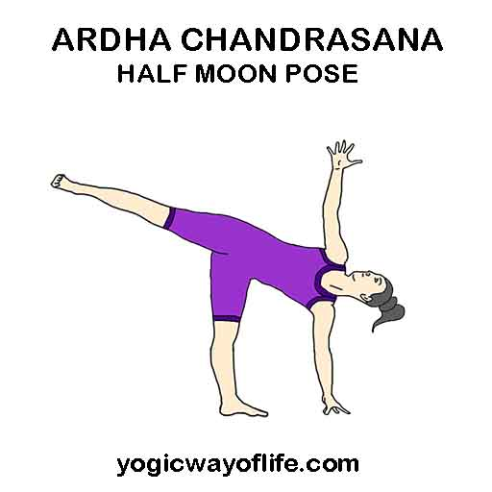

1. **Kailasasana**

**Benefits :-**

• Stretches the hips, works and relaxes the pelvic floor, and strengthens the

legs.

• Strengthens and brings flexibility to ankles and shoulders.

• Helps in flat foot correction and recovery in Achilles tendon.

**Limitations :-**

• Severe back ache should not do this posture.

**Modifications:-**

• People with High BP can avoid raising the palms above and instead

can hold them in front of your chest.

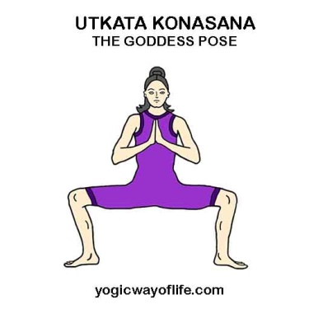

1. **Upavesasana**

**Benefits :-**

• The vertebral column and heart are strengthened.

• Good for regulating the menstrual cycle

• Cures indigestion.

• Strengthens arms and legs and helps to remove lethargy

**Limitations :-**

Recent or chronic injury to the legs, hips or shoulders.

**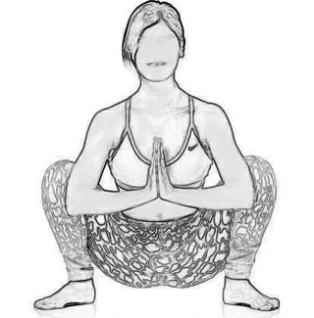**

SITTING ASANAS

1. **Utthita Dandasana**

**Benefits :-**

• Fixes spine related problems

• Pelives Asthma

• Reduces sciatica pain

• Reduces stress

• Stregthens back museles

• Streches shoulder & chest

• Helps to calm brain cells

**Limitations:-**

Do not attempt this asana if you have wrist or spine related injuries.

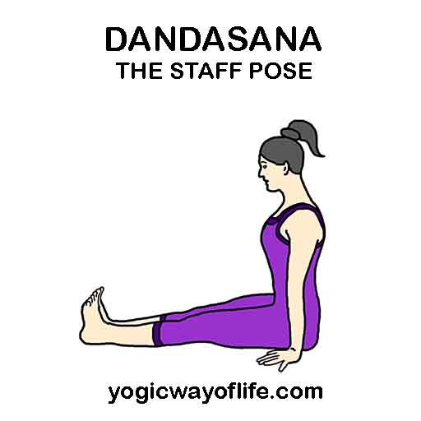

1. **Pashchimothanasana**

**Benefits :-**

• Gives flexibility to the back bone, stimulates spinal nerves and back muscles.

• Energizes the whole body and helps in relieving constipation

• Stretches your shoulders, spine and hamstring muscles

• Results in better digestion, increases your appetite.

• Good for reducing weight and obesity

• Highly beneficial in cases of high BP, sinusitis and asthma

• Relieves symptoms of dysmenorrheal and menopause

• Soothes anxiety headance and helps reduce fatigue Relieves stress and tension by calming the brain.

**Limitations:-**

People with heart ailments, back problems and spondylosis should avoid this asana

**Modifications:-**

* You may use a strap around your feet If you cannot reach your toes.
* To intensify the pose, place a block in front of your feet and interlace
* your hands around the blocks, as if it is an extension of your feet.

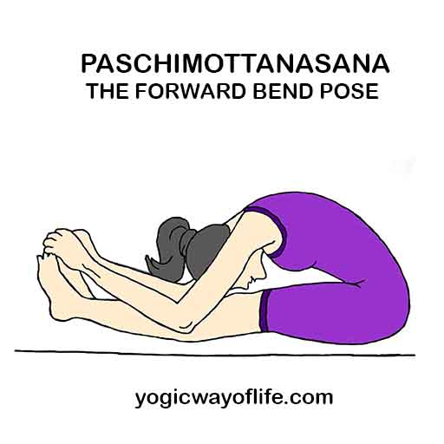

1. **Janu Shirasana**

**Benefits :-**

• Calms the brain and helps relieve mild depression.

• Stretches the spine, shoulders, hamstrings, and groins.

• Stimulates the liver and kidneys.

• Improves digestion

• Helps relieve the symptoms of menopause

• Relieves anxiety, fatigue, headache, menstrual discomfort.

• Strengthens the back muscles during pregnancy (up to second trimester),

done without coming forward, keeping your back spine concave and front torso long.

**Limitations:-**

Asthma, Diarrhea can avoid this posture.

**Modifications:-**

• Knee injury : Don't flex the injured knee completely and support it on a folded blanket.

• You can hold the foot and stretch your spine in case you're not able to bend forward.

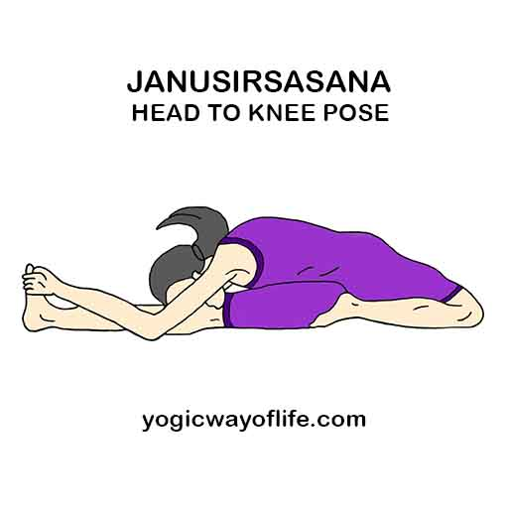

1. **Parivritha Janu Shirsasana**

**Benefits:-**

• Stretches the spine, shoulders, throax and hamstrings

• Stimulated abdominal organs such as the liver and kidneys.

• Improves digestion

• Lateral twist tones the spine and relieves backaches.

• Clears the urinary tract, improves vitality and cures impotency.

**Limitations:-**

• Avoid this posture if you have nausea or diarrhea

**Modifications:-**

• Bend laterally and try to hold the ankle with one hand stretch the other hand as much possible initially.

1. **Trianga Mukhaikapada Pashchimothanasana**

**Benefits:-**

• It opens the hips.

• It improves digestion and tones the abdominal organs

• Creates Flexibility in the knees.

• Decreases swelling and discomfort from a sprained ankle.

• Recommended for persons suffering from dropped arches and flat feet.

**Limitations:-**

• Severe back pain people can aboid this posture.

**Modifications:-**

• Beginners can keep the bent knee turned towards the side since it would be difficult for them to stretch.

1. **Ardhabadda Pashchimothanasana**

**Benefits:-**

• This asana benefits the liver and spleen; both organs play a part in the digestive processes.

• Gastric problems and constipationg are also alleviated with this asana.

• In this posture, the foot of the bent leg applies and intense massage to the inner abdominal organs.

• This will helps to stimulate intestinal peristalsis and alleviate constipation.

• Stretches the muscles of the back and increases blood circulation to the spinal nerves

• Stretches and tones the hamstrings and calf muscles.

**Modifications:-**

• Keep the other foot below your thigh if you're not able to do the posture in half – lotus position.

1. **Upavista Konasana**

**Benefits:-**

• Stretches the insides and backs of the legs

• Stimulates the abdominal organs

• Strengthens the spine

• Calms the brain

• Stretches the hamstrings and reduces the sciatic pain

• The pose also helps make the groin and the spine flexible

**Limitations:-**

Hamstring or groin injury people should not to this posture.

Modifications:-

Placing a blanket under your hips will be helpful.

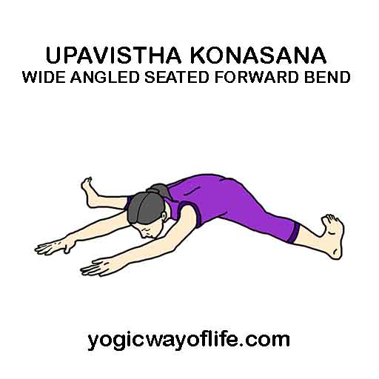

1. **Kurmasana**

**Benefits:-**

• This pose helps stretch and strengthen the back and legs.

• It helps to improve the functioning of the digestive and respiratory systmes.

• The organs in the abdomen are atimulated during this posture.

• The posture helps you to spread out both your shoulders and your hips

• The spine is elongated during the practice of this yoga posture

• Any tightness that is present in the lumbar and sacrum areas are released during this pose.

**Limitations:-**

Menstruation or pregnancy women severe back pain and heamia people should not do this posture.

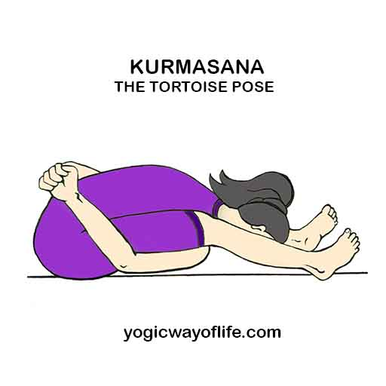

1. **Poorvothanasana**

**Benefits:-**

• Strengthens the arms, wrists and legs.

• Stretches the shoulders, chest, and front ankles.

**Limitations:-**

• Wrists injury must avoid this posture

**Modifications:-**

• With a neck injury, support the head on a wal or chair seat.

1. **Marichasana**

**Benefits:-**

• Massages abdominal organs, including the liver and kidneys.

• Helpful in treating diabetes as stimulates the pancreas. Strtcges the shoulders the brain.

• Relieves mild backache and hip pain

• Stretches the stretches the spine

**Limitations:-**

• Severe back pain people can avoid this posture.

1. **Vakrasana**

**Benefits:-**

• Reduces fat from waist

• Massages the internal organs such as kidney, pancreas, spleen, liver an daadrenal gland

• Stretches the spine resulting in vertebras movement.

• Tones up the central nerves and at the same time increases the flexibility of the spinal column

• Excellent posture for sciatica pain.

• Very beneficial for the patients having stone in gall - bladder

**Limitations:-**

• Recent abdomen surgery can avoid this posture

**Modifications:-**

• Beginners can perform the variation by placing the elbow against the side of the knee and twisting.

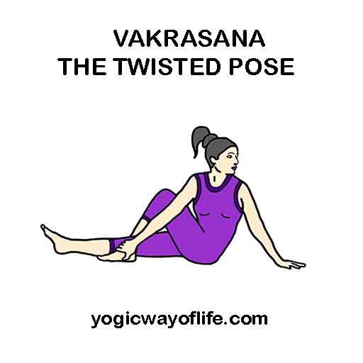

1. **Ardha Mastyendrasana**

**Benifits:-**

• Tones and strengthes abs and obliques

• Stretches and energizes the spine and opens the shoulders, neck, and hips

• Increases flexibility, expecially in hips and spine

• Improves digestion and elimination of wastes

• Relieves symptoms to backache, fatigue menstrual discomfort and sciatica

• Stimulates liver, heart, lungs, kidneys and spleen

• Releases excess heat and toxins from organs and tissues

**Limitations:-**

• Should be a avoided during pregnancy and menstruation due to the strong twist in the abdomen

• People with heart, abdominal or brain surgeries should not practice this asana

**Modifications:-**

• In case you are not able to grab your foot in this pose, you can push triceps against the side of the knee for better twinst.

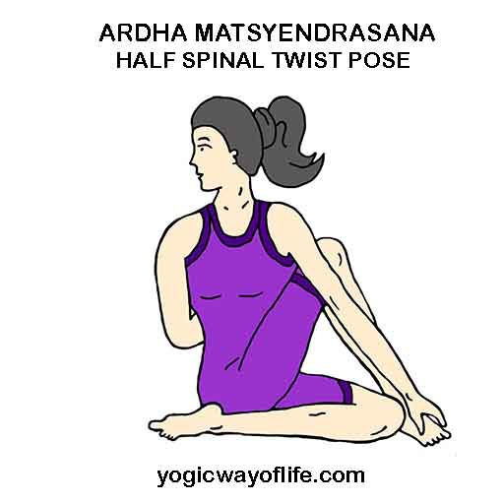

1. **Bhoonamanasana**

**Benefits:-**

• This asana stretches the spine and lower back, making the muscles supple and stimulating the nerves.

**Contraindications:**

• People with back problems, peptic ulcer, hernia, hyperthyroidism, high blood pressure or heart problems should not practise this asana.

1. **Krounchasana**

**Benefits:-**

This pose increases strength and flexibility in the joints and muscles of the legs.

Tones up the organs and the muscles of your chest and abdomen.

Stretches the ankles, the arch of the foot as well as the Achilies Heel.

**Limitations:-**

• Ankle or knee injuries and women during menstrual cycle must avoid this asana

**Modifications:-**

• Place a yoga strap around the sole of your foot before you try straightening your leg.

1. **Vajrasana**

**Benifits:-**

• Only asana that can be performed even after having heavy food.

• Dyspeptics will derive much benefit

• The nerves and muscles of the legs and thighs are strengthened

• Myalgia in the knees, legs, toes and thighs disappears

• Sciatica vanishes

• Flatulence is removed

• It is versatile posture well suited for meditation

**Limitation:-**

• People with osteo arthritis of the knees to aboid this posture.

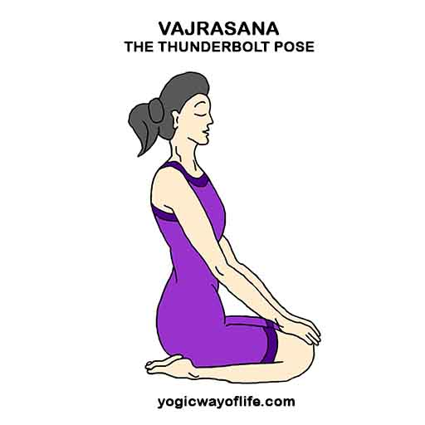

1. **Ustrasana**

**Benifits:-**

• Makes the spine flexible, incereases the circulation of blood to head region.

• This asana gives a good stretch to the back, chest, hips, groins and neck muscles and is helpful for back pains, stooping shoulders and also for correcting postural defects of the spine.

• It tones the digestive, excretory and reproductive organs.

• Ushtrasana improves the flexibility of the spine.

• It expands the chest and improves capacity.

**Limitations:-**

• High or low blood pressure

• Migraine

• Insomnia

• Serious low back or neck injury should aboid the posture.

**Modifications:-**

• Initially Ardha Ustrasana can be performed by placing the palms behind the waist.

• This asana can be performed with the pelvic area close the wall support and the arch back with the raised chest.

• Use a folded mat for the knee support if you have knee problems.

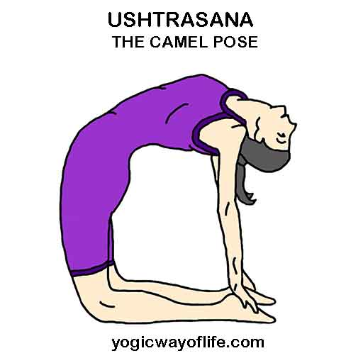

1. **Suptha Vajrasana**

**Benifits:-**

• Stretches the quadriceps and eases out any aches in the legs.

• Good for the pelvic region: abdominal organs & digestions.

• Gives rest to the legs for those who are required to stand for a long time, walk long distances or athletes. Practice this asana with sarvangasana after long walking.

• Counter pose for paschimottanasana

**Limitations:-**

• Low back or hip injury people should not do this posture.

**Modifications:-**

•Initially you can keep the knees separated if the posture is very tough

• Ardha supta vajrasana can be performed by supporting the body weight on the elbows and raising the chest.

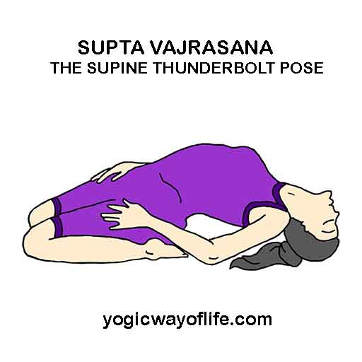

1. **Vyaghrasana**

**Benefits:-**

• Brings flexibility to the spine

• Strengthens wrists and shoulders

• Massages the digestive organs and improves digestion

• Tones the abdomen

• Relaxes the mind and improves blood circulation

**Limitations:-**

• Severe back pain people to avoid this posture

**Modifications:-**

• People with neck injury can look in front and keep your body in line with neck rather looking above and below.

1. **Pharighasana**

**Benefits:-**

• Stretches your hamstrings.

• Stretches your adductor muscles and your calf muscles

• Stretches the accessory muscles of breathing between your ribs

• Stretched you torso muscles.

**Limitations:-**

• Knee arthritis and ankle injury can aboid this posture

Modifications:-

• You can place a soft cushion under your knee if the pain is more.

1. **Pincha Mayurasana**

**Benefits:-**

• Effectrive remedy for diabets and piles.

• It tenes up the digestive organs

• It also stimulates the lungs and helps in its proper functons.

**Limitations:-**

• Wrist shoulder or clbow injury

• Heart diseases

• High blood pressure

• Intestinal problems

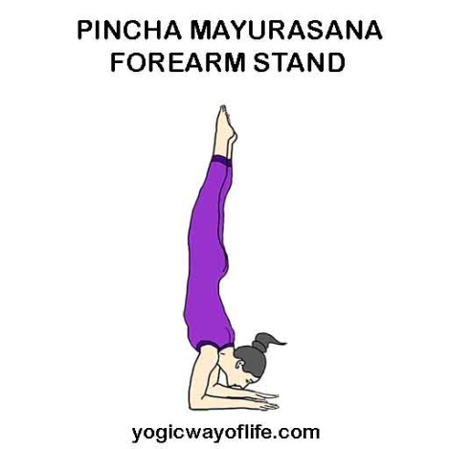

1. **Shirshasana**

**Benefits:-**

• Increases Stamina and strength and promotes good posture

• Increase blood circulation in brain and improve brain function and memory

• Improves digestion

• Those suffering from liver disease, headache, poor blood circulation, this asana is very beneficial.

• Strengthens the muscles of the neck, back and shoulder

• Stimulates the Endocrine System

• Relaxes the mind and helps to improve mental balance

• Stimulate and regulates all the body system.

**Limitations:-**

• Chronic Neck pain

• Spinal Injury

• Glaucoma

• Vertigo

• Ear & Eye Infection

• Recent hear surgery

• Pregnant ladies must avoid this posture.

**Modifications:-**

• Take wall support initially to perform this asana and

slowly move away from the wall as you gain confidence.

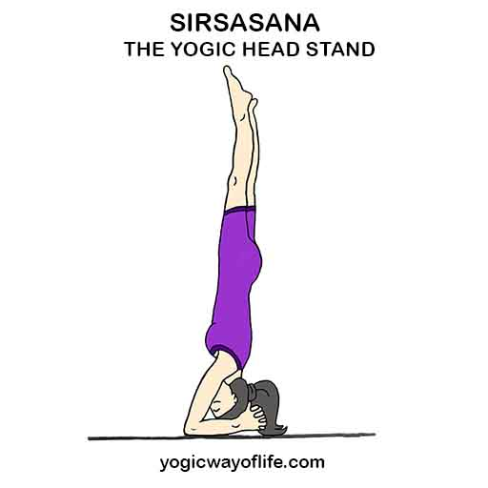

1. **Shashankasana**

**Benefits:-**

• Enhances blood flow to the head, stimulates the brains, gives flexibility to the spine, knees and ankles. A good posture for breathing ailments.

**Limitations:-**

• Patients with gastritis and peptic ulcer may avoid this posture.

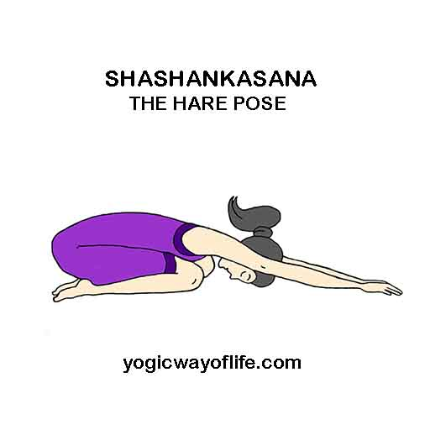

1. **Veerasana**

**Benefits:-**

• Thighs and calves get extended and toned.

• Stretches the thighs, knees, and ankles

• Strengthens the arches

• Improves digestion and relieves gas

• Helps relieve the sumptoms of menopause

• Reduces swelling of the legs during preganancy(through second trimester)

• Therapeutic for high blood pressure and asthma

**Limitations:-**

• Heart problems.

• Headache:Practice this ose lying back on a bolster.

• Knee or ankle injury : Avoid this pose

**Modifications:-**

• If your ankles are painful in this pose, roll up a towel and place it underneath them before you sit back.

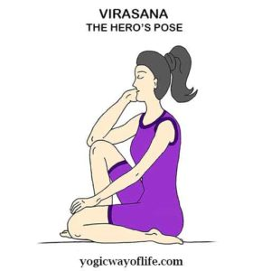

1. **Supta Veerasana**

During this asana shoulds arms & legs gain strength

**Benefits:-**

• Stretches the abdomen, thighs and deep hip flexors(Proas), knees, and ankles

• Strengthens the arches

• Relieves tired legs

• Improves digestion

• Helps relieves the symptoms of menstrual pain

• The spinal colum becomes elastic and its functioning improves

• There is pressure on the digestive organs and the belly gets stretched, which promotes their functioning.

• This Asana helps in breath - control hence this asana is very useful for singers, orators and public speakers.

• This Asana is suitable for pranayama.

Limitations:-

• If you have any serious back, knee, or ankle problems aboid this pose.

**Modifications:-**

If you're not able to recline fully on the floor, set a bolster or one or more folded blankets behind yourself to fully support your spine and head. Use as much height as you need to make the position reasonably comfortable.

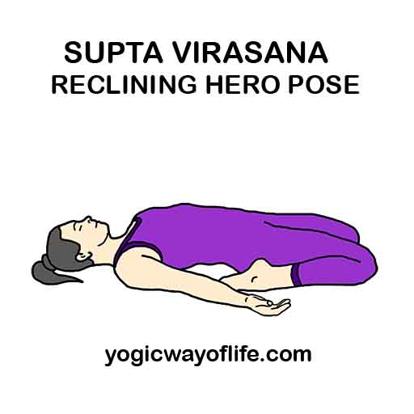

1. **Paryankasana**

**Benifits:-**

Streches the quadriceps : The pose creates a deep strectch at the apper thigh area at the qudricep muscles and this stretch further improves the fixibility of these muscles. Expands the chest and the lungs:

In this pose the chest and the lungs fully expand thus increasing oxygen uptake.

**Precautions:-**

• Cardiac problems

• Hypertension

• Serious knee injuries

• Sciatica

1. **Simhasana**

**Benefits:-**

• Relians tension in the face and etest.

• Improves circulation of blood to the face.

• Keeps your eyes healthty by stimularing the nerves.

• Helps prevent sore throat, asthma and other respiratory aliments.

**Limitations:-**

Do not practice this asana, if you suffer from any chronic illnesses or physical problems.

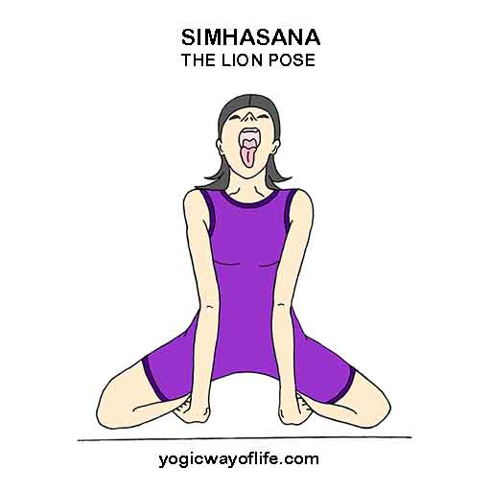

1. **Mandukasana**

**Benefits:-**

• Relieves breathlessness, dizziness fatigue and headaches

• Reduces high blood pressure

• Stretches and tones the spine, relieving pain in the back and neck

• Refuces acidity and flatulence.

• Alleviates menstrual pain and depression associated with menstruation.

• May reduce hot flushes experienced during.

**Limitations:-**

• Do not practice this asana if your have

• Osteoarthritis of the knees

• bronchitis

• diarrhea

• incontinence

**Modifications:-**

• A blanket may be positioned between the calves and hips for more support.

• A towel roll under the ankles can reduce pressure to the ankle joint.

• Also, some students enjoy a sandbag placed over the hips to increase the feeling of being grounded, safe and secure.

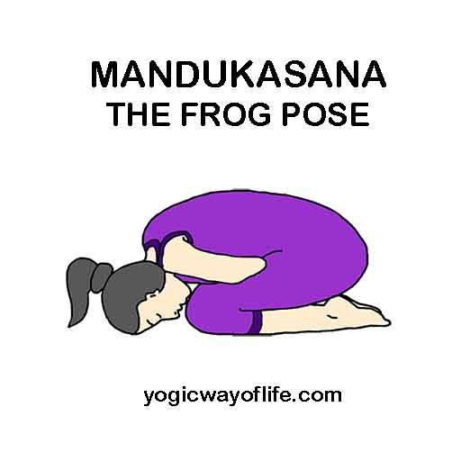

1. **Padmasana**

**Benefits:-**

• Sitting / meditative

• Erects the spine, It's a symmetrical posture, brings stability to the mind.

**Limitations:-**

• Patients will rheumaiold arthritis should avoid this posture.

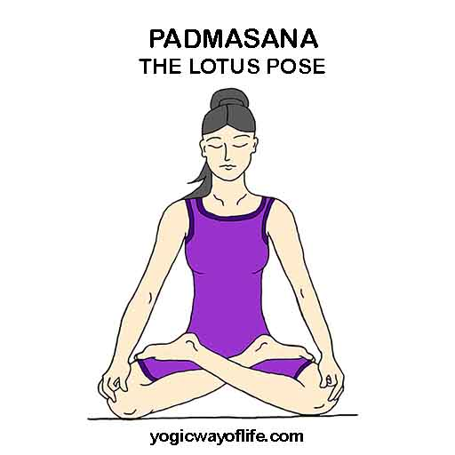

1. **Padma Parvatasana**

**Benefits:-**

• Improves the sense of balance and ability to concentrate. Stimulates respiratory function and calms the entire nervaus system and arm muscles and helps with hip displacement.

**Precaurions:-**

• High blood pressure

• Ankle injury

• Knee injury

• Migrance

1. **Utthitha Padmasana**

**Benefits:-**

• Strengthens and tones, the arms, biceps and triceps

• Also flexes the joints, shoulders, elbows and wrists.

• Strengthens the muscles in the abdominal region and promotes digestion.

**Limitations:-**

• Knee injury and ankle injury can avoid this posture.

**Modifications:-**

• For beginners place right ankle on top of left thigh and perform ankle rotation - repeat on the other side.

• Place right ankle on top of left thigh and push the knee up and down - repeat on the other side.

• Baby caring pose

• Baddha konasana or butterfly stretch loosens the thighs and hips.

1. **Padmanamanasana**

**Benefits:-**

• Relaxes the body and mind hence recommended for pranayama and meditation.

• The spine and abdominal region is toned

• Removes stiffnes from the knee joints.

• Corrects Postural defects of the spine.

**Limitations:-**

• People suffering from sciatica, severe arthritis, weak or injured knees and those who have undegone knee or spinal surgery should not perform this posture.

Modifications:-

• Sit in half - lotus pose initially to aboid discomfort.

1. **Yogamudrasana**

**Benefits:-**

• Stimulates the digestive fire. It cures problems related to the stomach like gas, indigestion, chronic constipation, etc.,

• Body becomes shapely, flexible and strong.

• Problems related to the intestines are cured.

• This asana strengthens the heart and cures blood related disorders.

• Leprosy and disorders or reproductive system are eliminated.

• It enhances mental efficiency and intellectual prowess.

• It tones up the nervous system, particularly the lumber plexus.

• Stimulates the pancreas controlling diabetes. This asana is beneficial for diabetics.

• The manipura chakra gets activated, which is the main center of the dormant energies lying within every individual.

**Limitations:-**

Knee arthiritis and ankle injury can avoid this posture.

**Modifications:-**

If you are not able to hold the big toe from behind you can just hold your palms behind and bend forward.

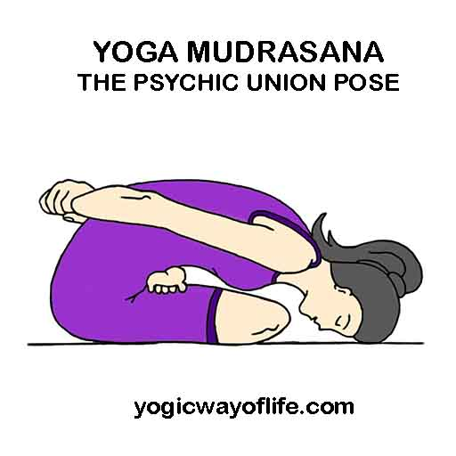

1. **Poorna Mastyasana**

**Benefits:-**

• Opens your pectoralis muscles of your chest, the intercostal muscles between your ribs, and upper portion of psoas muscles in your hips.

• Improves the quality of your breath by opening the accsory muscles of breating

• Opens muscles in your abdomen and in the front of your neck

• Relieves thoracic and mid back spinal tension

• Strengthens musculature in your back and neck

• Traditionally thought to stimulate organs in the abdomen and throat

**Limitations:-**

• High BP

• Abdominal or thoracic surgery

• Cervical spondylosis must not perform this asana

**Modifications:-**

• If you're not able to fold the legs in padmasana, legs can be folded in sukhasana

• If you have problems folding the legs, half fish pose(Ardha matsyasana) can be done with straightened legs.

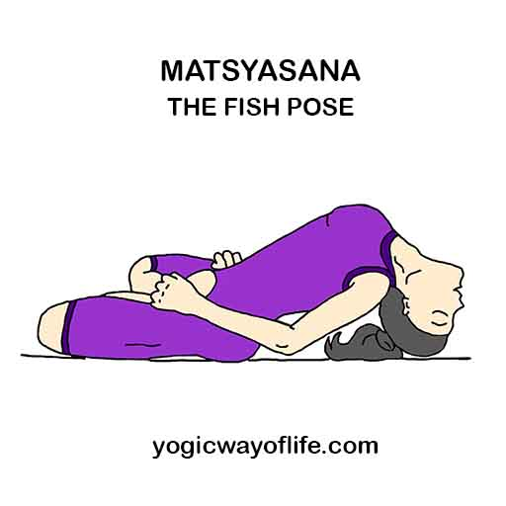

1. **Bharadhvajasana**

**Benefits:-**

• Provides a deep and complete stretch to the body along the backbone, trunk, shoulders, and hips.

• It is well suited for pregnant women, being an exercise without any pressure eserted on the belly.

• The pose soothes and regenerates underlying organs in the abdomen and body.

• It results in enhanced metabolic activity, and digestive function.

• The twist soothes the mind and relieves the pain in neck and lower back.

**Modifications:-**

• This pose can be performed on the chair if the person is suffering from arthritis.

**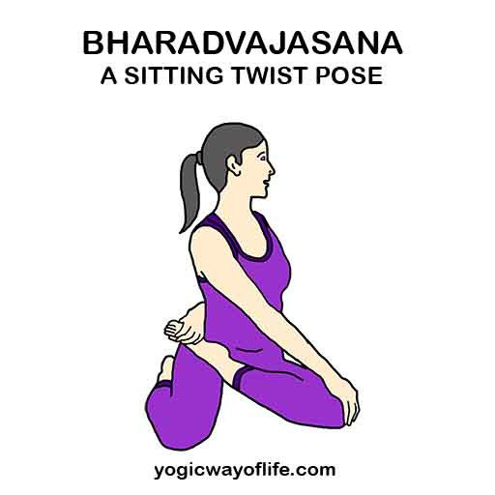**

1. **Baddakonasana**

**Benefits:-**

• Stimulates abdominal organs, ovaries and prostate gland, bladder, and kidneys.

• Stimulates the heart and improves general circulation.

• Stretches the inner thighs, groins, and knees.

• Soothes menstrual discomfort and sciatica

• Helps relieve the symptoms of menopause

• Therapeutic for flat feet, high blood pressure, infertillity and asthma

• Consistent practice of this pose until late into preganancy is said to help ease childbirth

**Limitations:-**

• Hernia and abdominal injury people can aboid this posture

**Modifications:-**

• It can be difficult to lower the knees toward the floor. If your knees are very high and your back rounded, be sure to sit on a high support, even as high as a foot off the floor.

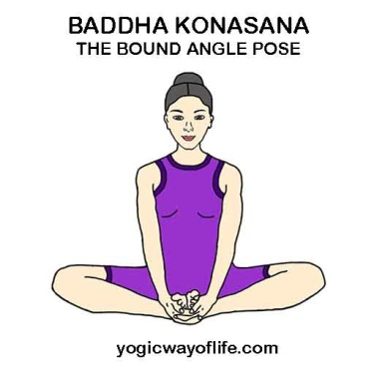

1. **Kakasana**

**Benefits:-**

• Balaroing the body via arms & wrists.

• If builts the course strangth & tones your belly.

• Improves digestion.

**Limitations:-**

• People suffering migrane should avoid people having weak wrists.

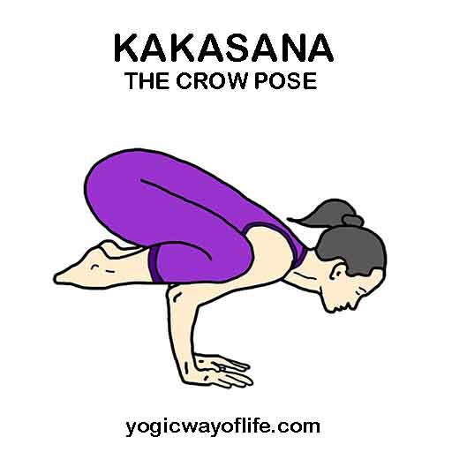

1. **Bakasana**

**Benefits:-**

• Strengthens wrists arms abdomen and shoulders.

• originates a sense of physical balance and co - ordination.

• Balance nervous system.

**Precautions:-**

• People who suffer from any of this conditions must avoid practicing Bakasana recent wrist or shoulder injury, heart problems, carpal tunnel sysndrome or cerebral thrombosis.

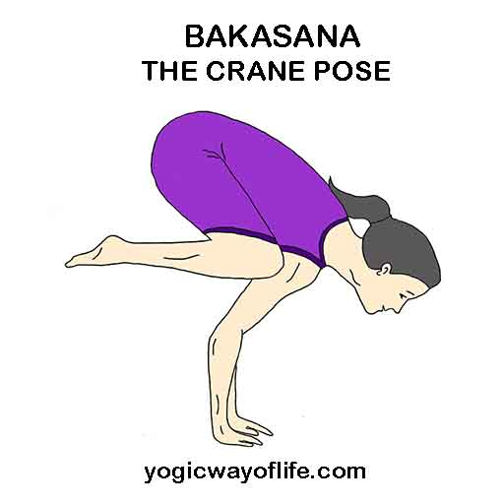

1. **Hamsasana**

**Benefits:-**

• It strengthns your abdominal muscles

• This pose brings more strength to your arms

• It clears constipation and digestion

**Limitations:-** People with cardiac hernia, kidney or liver problems should attempt this asana after first consulting a physian.

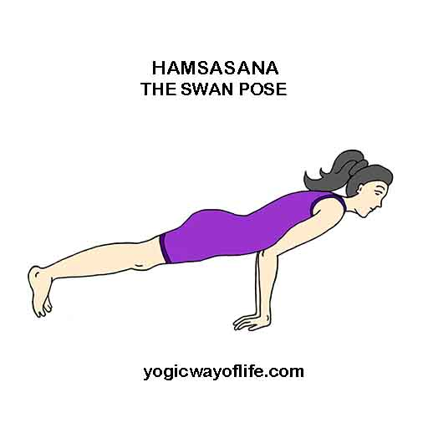

**PRONE ASANAS**

1. **Makarasana**

Benefits:-

• Lengthens the spine gently

• Release lower back compression

• Relaxes the body

• Calms the mind

• Therapeutic for high blood pressure

• Helps relieve fatigue

Limitations:-

• Pregnancy - can avoid this posture

Modifications:-

• You can rest your forehead on a block or blanket instead of your hands.

• Tuck your toes under to intensify the stretch in your calves.

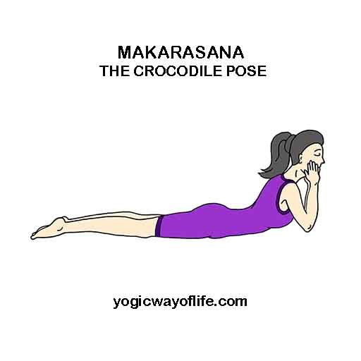

1. **King Bhujangasana**

Benefits:-

• Strengthens the spine and removes back ache

• Stretches chest and lungs, shoulders, abdomen firms the buttocks

• Stimulates abdominal organs

• Strengthens the adrenal glands which is responsible for seceretions of adrenaline, cortisol and other stress hormones.

• Helps reieve strees and fatigue

• Expands and opens the chest which encourages deep breathing as well and helping to correct rounded shoulders.

• Helps the functioning of thyroid gland, which is responsible for metabolic activities.

• Useful for slipped disc and sciatica as it relieves the pains abd cab aksi rekicate the slipped disc

• Traditional texts say that Bhujangasana disease, and awakens kundalini.

Limitations:-

• Back injury

• Carpal tunnel syndrome

• Headache

• Pregnancy should avoid this posture

Modifications:-

• Brace a metal folding chair against a wall, and do the pose with your hands on the front edge of the seat, balls of the feet on the floor.

• Beginners can do the baby cobra pose by resting the elbows instead of the palms.

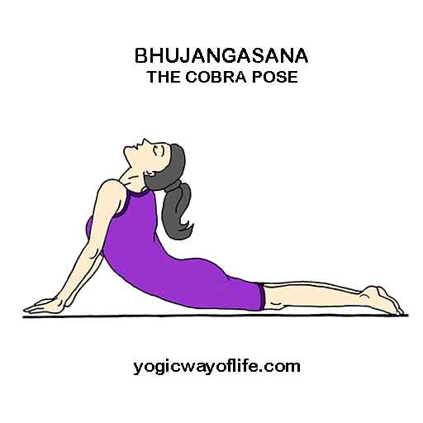

1. **Baby Bhujangasana**

Benefits:-

• Its ability to increase the flexibility of the spine.

• It stretches the chest while strengthing the spine and shoulders.

• It also help to open lungs, which is ttherapeautic for asthma.

• This also stimulates the abdominal organs improving digestion Precutions.

• Don't keep your body stiff

• Don't force yourself too much practicing it.

1. **Seal Pose**

Benefits:-

• Mechanic the main stimulation taking place in the seal pose is compression of the lumbar apiner energeric. Targets the urhary bladder kidney pathways relared to the water element and stomach - spleen related to the earth element.

Contraindications : Be cautions in case of a back problem or wrist/elbow and shoulder injury.

1. **Shalabasana**

Benefits:-

• Strengthens the muscles of the lower back, buttocks, and backs of the arms and legs

• Praticularly recommended for relieveing lower back pain and sciatica

• Stretches the shoulders, chest belly, and thighs.

• Improves sposture

• Stimulates abdomial organs

• Helps relieve stress

Modifications:-

• Beginners can practice shalabasana-A, raising one leg at a time and then repeating on the other side.

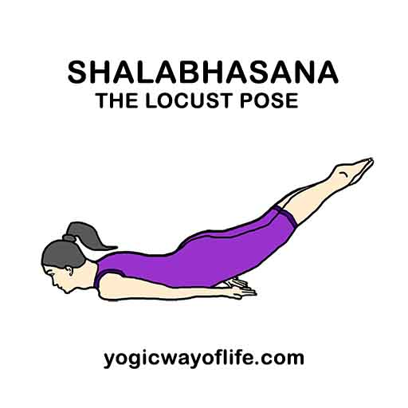

1. **Sarpasana**

Benifits:-

• Sarpasana helps to all the organs of abdomen get proper massage.

• Stongthens chest and shoulders

• Strengthens the lungs and heart and you can get the balanced heart beat.

• Increases appetite and therapeutic in constipation, indigestion, diarrhea, diabetes acidity and wind troubles.

Contraindications: People sufforing from peptic ulcer, hernia, intestinal tuberculosis or hyperthyroidism should not practice this asana without the guidance of a competent teacher.

1. **Urdhvamukha Shvanasana**

Benefits:

• Highly benefitcial for wrists. The pose helps in strengthening the wrists as the body weight is on the wrists.

• Lower back will also benefit from the pose as it stretches the lower back muscles.

• Stretches the muscles of the chest and shoulders.

• Stimulates and tones the abdominal muscles and organs

• Helps improve the overall posture of the body.

Limitations:-

• Wrist or shoulder injury

• Severe lower back pain and pregenant ladies can avoid this posture.

Modifications:-

• Beginners can ground the knees initially for better support.

1. **Adhomukha Shvanasana**

Benefits:-

• Elongates and releases tension from your spine.

• Stretches your hamstings, calves, arches and hands.

• Strengthens your arms, shoulders and back

• Improves mobility of your digestive system

• Relieves back pain, headaches, insomnia and fatigue

• Helps relieve the sumptoms of menopause

• Downward - Facing Dog is a mild inversion that calms the nervous system and helps relieve strees

Limitations:-

• Wrist problems like carpal tunnel syndrome.

• High blood pressure

• Eye or inner ear infection

• Avoid this pose in late - term pregnancy

Modifications:-

• Ease Pressure on your wrists by placing a wedge under your palms or performing the pose on your elbows.

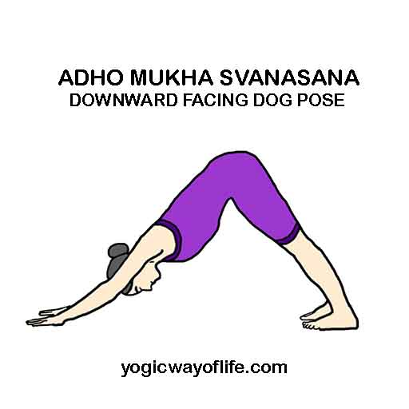

1. **Chaturanga Dandasana**

Benefits:-

• Strengthens the muscles of the wrists.

• Strengthens the biceps and triceps.

• It also strengthens and stretches the spinal muscles and

• Provides relief from chronic back problems.

• Tones the abdomen and strengthens the core abdominal muscles

Limitations:-

• Wrist or shoulder injury and pregnant ladies can avoid this posture.

Modifications:-

• Beginner should drop his / her knees to the floor unill he / she is able to support the body with arms.

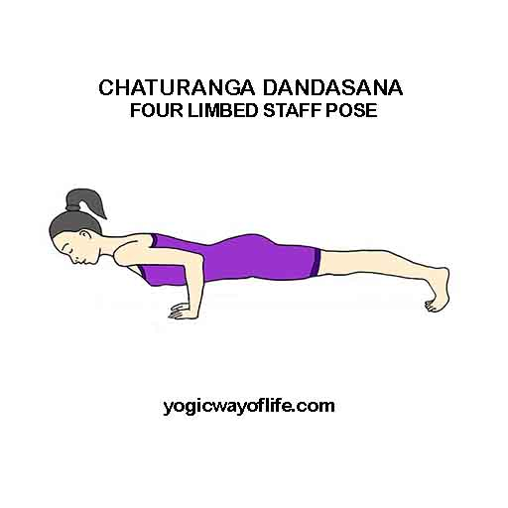

1. **Dhanurasana**

Benefits:-

Streiches the chest and lungs.

Stimulates the thyroid and pituitary.

Praecaustions:-

Dont practice this asana if you have neck or lower back injuries.

Do not practice this asana if you have undergone any abdominal suregery recently

Avoid this asana if your have problems like high blood pressure, ulcers, migrane headache or hernia.

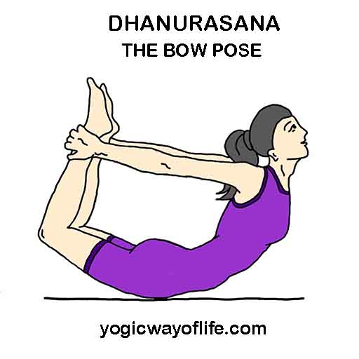

1. **Bekasana**

Benefits:-

This improves the over all flesibility of the body, especially of legs, back, care, shoulders and neck. It strengthens the body and improves over all body posture.

Precautions:-

If you are suffering from any issues or inflammation in the stomach do not perform it. Also if you are having any surgery in the stomach region avoid bekasana.

1. **Eka Pada Bhekasana**

Benefits:-

• It is a very good pose for rejuventing the knee joints as the psoasmuscles and quadriceps are stretched in this pose.

• This pose is beneficial for the back as it strengthens the muscles of the back. It helps to improve posture as well.

• It improves digestion by stimulating the abdominal organs.

• This pose stretches the entire front and back of the body and strengthens the joints and muscles throughout the body.

• It stretches the throat, chest and abdomen, groin, thighs and ankles.

• Helps in flat foot correction or fallen arches in the foot.

Limitations:-

• Avoid the post if you have any neck, shoulder or lower back injuries

Modifications:-

• The bolster should be placed under the beginner's lower ribs as this will help him/her to lift the upper body better. The beginner's free arm should be pressed onto the floor in front of this prop.

1. **Ashwasanchalanasana**

Benefits:-

• Provides strength to thighs, groins and chest.

• Enhances the functioning of the abdominal organs.

• Increases the breathing capacity of the lungs.

• Stretches the shoulders, armpits and neck.

• Tones the kidney and liver and stimulates abdominal organs;

Limitations:-

Not for people suffering from heart problems, hernia or lower back pain.

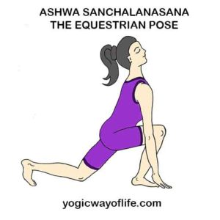

1. **Hanumanasana**

Benefits:-

• Hanumansana helps to strectches the thighs hamstrings and groins.

• If helps to stimulate the abdominal organs.

• This is the excelling test of leg flexibility at the hips

• This asana is very useful in treating or preventing of sexual problems.

Contraindictions : Avoid this asana if your have groin or hamstring injuries. Those with chronic shoulder injuries should aboid Purna Hanumanasana. Do not force this pose and modify with bolstern.

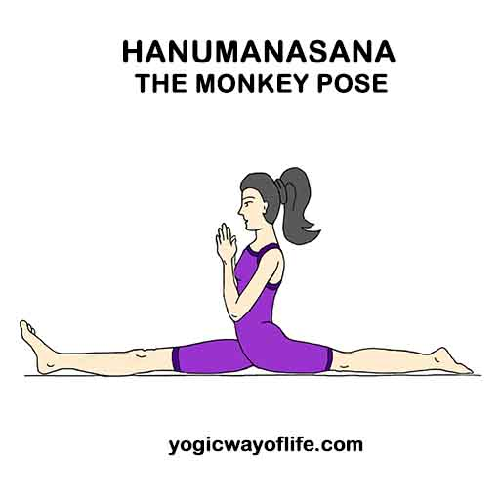

1. **Raja Kapotasana**

Benefits:-

• Streches the thighs, grains and psoas, abdomen, chest and shoulders and neck.

• Stimulates the abdominal organs.

• Opens the shoulders and chest.

Limitations:

To avoid practicing this asana if you have tight hips or thighs.

1. **Kapotasana**

Benefits:-

• Kapotasana reduces the stiffness in the shoulders, back and hips.

• Kapotasana increases the elasticity in your spine, thighs, calf muscles, arms, shoulders and hands.

• This asana strengthens the muscles and joints of your lower limbs and also givs them a good strech.

Precautions:-

• Do not preform this pose if you have low or high blood pressue.

• People offected by insomnia hypertension and migraine should avoid this pose.

• Do not practice this pose in case of serious low back or nech injury.

1. **Ananthasna**

Benifits:-

• Ananthasana is very beneficial to people suffering from problems like sciatica, arthritis, hypertension, Peptic ulcers, and colitis.

• It stretches and strengthens the sides of the tors.

• It increases the flexibility of the spine and muscles in the legs.

• The hamstrings are stretched and strengthened, which increses their efficiency

• It reduces the obesity of the hips and thighs through the stretching action.

• It also helps in the development of the pelvic region and prevents problems like hernia by toning muscles.

• It also helps in improving overall body balance

• It is also beneficial in correcting menstrual disorders and edema of the arms or legs.

Limitations:-

• Hip injury and hernia people can aboid this posture.

Modifications:-

• This asana can be practiced by using the wall support against the back for beginners.

• If it is difficult for you to grab your toes with your hands, use a piece of cloth, place it over the sole of your foot and grab it to pull.

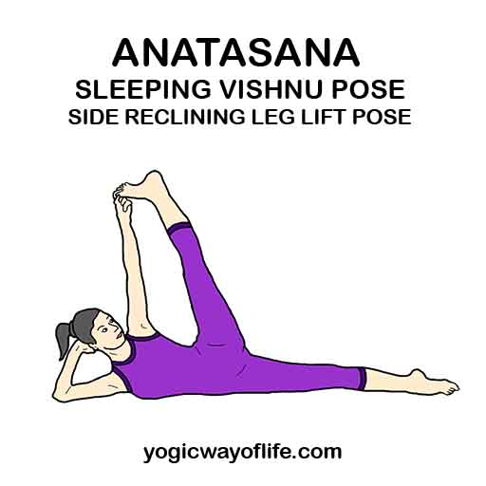

1. **Vasistasana**

Benefits:-

• Strengthens the arms, abdomen and legs

• Strengthens the wrists

• Improves sense of balance

• Tones and strengthens the core, with a focus on the oblique muscles

• Tones the inner thigh muscle when top leg is lifted

Limitations:-

• Wrist injury and hip injury beople can avoid this posture

Modifications:-

• Slightly bend your knees toward the floor to achieve a greaters sense of balanc

• You could also rest your forearm on the ground and use it as support.

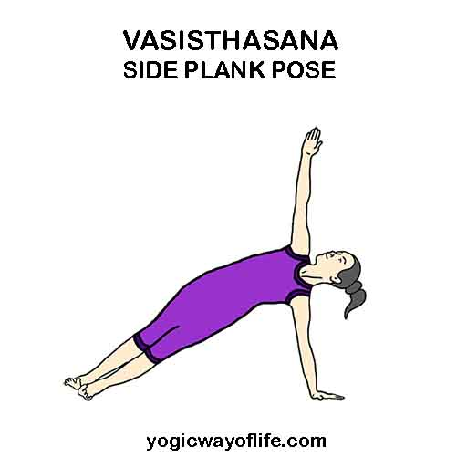

**SUPINE ASANAS**

1. **Setu Bandhasana**

Benefits:-

• Stretches the chest, neck, spine and hips

• Strengthens the back, buttocks, and hamstrings

• Improves circulation of blood

• Helps alleviate stress and mild depression

• Rejuvenates tired legs.

• Relieves symptoms of asthma and high blood pressure.

• Therapeutic for hypertension, osteoporosis and sinusitis.

Limitations:-

• Avoid this posture if you have a neck injury.

• Caution for late term pregnancy

• Knee injury.

Modifications:-

• Use a block or bolster under the hip to support the weight.

1. **Naukasana**

Benefits:-

• Strengthens the abdomen, hip flexors and spine

• Stimulates the kidneys, thyroid and prostate glands, and intestines

• Helps relieve street

• Improves digestion

Limitations:-

• Asthma

• Diarrhea

• Headache

• Heart Problems

• Insomnia

• Low blood pressure

• Menstruation

• Pregnancy

• Nech Injury: Sit with your back near a wall to perform this pose. As you tilt your torso back rest the back of your head on the wall.

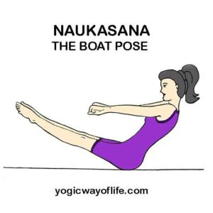

1. **Utitha Padasana**

Benefits:-

• Provides a good stretch to the hamstrings.

• Helps in reducing the abdominal fat

• Works on the quadriceps muscles and thighs.

Limitations:-

• People wiht abdominal surgery, hernia should not do this posture

Modifications:-

• People who are not sable to lift the leg up vertically can raise up to 45' - pada vrithasana

1. **Pavana Muktasana**

Benefits:-

• Pavanamuktasana cures acidity Indigestin and Constipation.

• Pavanamuktasana is very good for all abdominal organs.

• Regular practice pavanamuktasana cures gastrointestinal problems.

• Helpful for those suffering from gas problems, acidity, arthritis pain, heart problems and waist pain.

• Strengthens back muscle and cures back pain.

• It gives flat stomach. Everyone should practice this asana for flat stomach.

• Pavanamuktasana is very beneficial for reproductive organ and or menstruction disorder

Limitations:-

• Those suffering for high blood pressure, slip disc, ulcer should not do this asana.

• In pregnancy and menstruation women should not practice

Modifications:-

• Arthritis people who can't bend the knee can hold the thighs and press firmly instead on knees.



1. **Apanasana**

Benefits:-

• Eases tension in the lower back

• Massage the abdominal organs.

• Improves blood circulation.

• Rebalance your chergy.

1. **Sarvangasana**

Benefits:-

• Stretches your spine, neck and shoulders

• Stimulates your abdominal organs prostate and thyroid glands

• Results in better digestion

• Relieves menopausal symptoms Eases tension and fatigue relieve strees and tension

• Alleviates insomnia

• Highly therapeutic for infertility, sinusitis and asthma

Limitations:-

• Pregnancy

• High BP

• Neck injuries

• During Menstruation

• Headaches

• Diarrhea patients Must avoid this asana

Modifications:-

• Alternatively, viparita karani asana can be done with by raising the legs upand supporting your waist with the elbows.

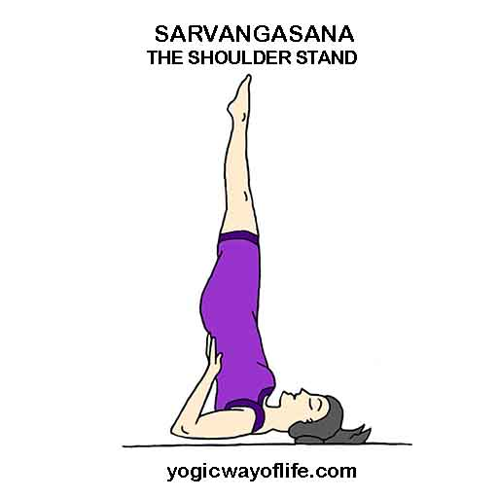

1. **Ekpada Sarvangasana**

Benefits:-

• Stimulates and keeps the thyroid healthy, Influences the pelvic organs. Useful in curing varicose veins, piles, hernia, constipation and menstrual disorders.

Limitations:-

• People with cervical spondylosis and severe ypertension should not do this posture.

1. **Pindasana**

Benefits:-

• Strengthens arms, shoulders and neck muscles.

• Relax the spine, especially the kumber spine.

• In creases hip and knee flesibility

• Improves digestive health

• Relax and stabilizes the mind and body.

Precautions:-

Those who are affected with sock pain, headache or high blood pressure should not perform this asana.

Those who have an injury in their knees shoulders, neck or hips should not proctise this asana

1. **Halasana**

Benefits:-

• Practicing this asana on a regular basis helps in strengthening your arms, shoulders, hands, wrists & legs.

• It gives a good stretch to your spine and keeps you away from backache problems.

• This asana stretches your belly muscles and helps in toning your abdominal organs.

• It increases your lungs capacity as well.

• This asana helps you in balancing your body and also improves your body posture.

• This asana helps in stimulating the thyroid gland.

• It even helps in reliving the symptoms of menopause.

• Furthermore it reduces problems like fatigue & insomnia.

• It is therapeutic for backache, headache, infertility & sinusitis.

• It helps in calming your mind & Helps relieve strees levels and attain peace

Limitations:-

• Neck injuries

• Lower back injuries can avoid this posture

Modifications:-

• If the legs are not reaching the floor, you can place them on a small chair.

• This pose can be done against a wall support and slowly walk your foor down as per the comfort level.

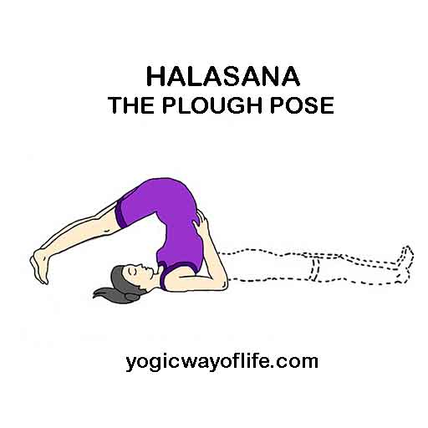

1. **Karnapidasana**

Benefits:-

• This is a soothing fetal positon that offers deeper spinal flexion and a more intense stretch of the hips.

• This also lends a great internal abdominal massage to the organs.

• Calms the brain.

• Stretches the shoulders and spine

• Helps relieve the symptoms of menopause

• Reduces Stress and fatigue

• Therapeutic for backache, headache, infertility, insomnia, sinusitis.

• It also stimulates the internal abdominl organs(helping aid digestion), thyroid, and prostate glands.

• This pose tones the thighs, buttocks, and hips while stretching the shoulders and neck.

• Alleviates : insomnia, fatigue, and negative symptoms of menopause.

• This pose may prove helpful against sinus problems (including asthma), headache, and infertility.

Limitations:-

• Diarrhea

• Women during menstruation

• Neck injury Must not perform this asana.

1. **Poorna Mastyasana**

Benefits:-

• Opens your pectoralis muscles of your chest, the intercostal muscles between your ribs, and upper portion of psoas muscles in your hips.

• Improves the quality of your breath by opening the accsory muscles of breating

• Opens muscles in your abdomen and in the front of your neck

• Relieves thoracic and mid back spinal tension

• Strengthens musculature in your back and neck

• Traditionally thought to stimulate organs in the abdomen and throat

Limitations:-

• High BP

• Abdominal or thoracic surgery

• Cervical spondylosis must not perform this asana

Modifications:-

• If you're not able to fold the legs in padmasana, legs can be folded in sukhasana

• If you have problems folding the legs, half fish pose (Ardha matsyasana) can be bone with straightened legs.

1. **Ubhaya Padhangustasana**

Benefits:-

• This pose strongthens the abdominals, the genital organs and relieves burning during urination. In the subtle body, this pose by balancing on the tailbone releases "Stuck energy" from the base of our spine helping the free flew of prana move up ward.

Contraindications:-

• Should not attempt this pose if there is an injury to any part of the body like the hips, shoulders, neck, arms, lower back etc.,

1. **Supta Padangustasana**

Benefits:-

• Alleviates stiffness in lower back and some kinds of backache

• Stretches hamstrings, calves, and inner thighs

• Relieves arthritis pain in hips and knees

Limitations:-

• Hamstring tear

• First and last variations; menstruation, pregnancy and diarrhea

• High blood pressure or a tight thoracic spine : Put a folded blanket under your head Modifications:-

• Beginners can hold the ankles and pull if they are not able to reach to the foot

• A strap can be used to hold the leg and pull towards for better stretch.

1. **Urdhva Mukha Paschimottanasana**

Benefits:-

• Strengthening shoulder, abdomen and spine.

• Increases focus, Improves blood airculation.

• Helps to stimulate reproductive organs.

• Helps to reduce belly fat.

Contraindications: Suffering from a migraine, hernia, hacirorrhoids, Irritable bowel syndrome (IBS) Blood Pressure, Fibromyalgia, slipped Disc etc, should avoid this asana

1. **Supta Trivikramasana**

Benefits:-

• Stretches and strengthens; A4 an achanced lovel, the hamstrings, pelvic floor muscles, giuteus maximus, and groin muscles are stretched. These when strecthed help to atrengthen the hips, the pelvis and the hip girdle.

Contraidications:

Injury in any part of the body should avoid this pose.

Recovering from any surgery to any port of the body or organ, is again a contraindietion and should be avoided.

1. **Jatara Parivartanasana**

Benefits:-

• Stretches the chest, obliques, piriformis and low back muscles.

• Can release tension from the pelvic floor.

• Massage the visceral organs, aiding digestion and elimination.

• Releases stored toxins

• Synthesizes the two hemispheres of the brain.

• Strengthens the body and centers the mind

Limitations:-

• Lumbar spine injury

• Hernia

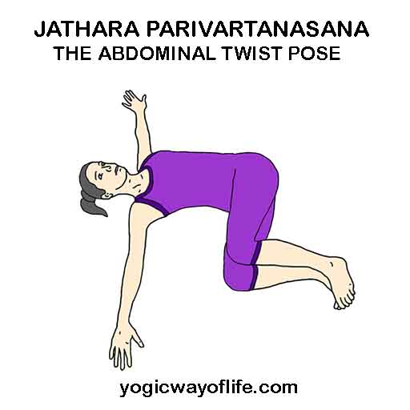

1. **Chakrasana**

Benefits:-

• Stretches the chest and lungs

• Strengthes the arms and wrists, legs, buttocks, abdomens, and spine

• Stimulates the thyroid and pitulitary

• Increases energy and counteracts depressin

• Therapeutic for asthma, back pain, infertility, and osteoporosis

Limitations:-

• Back injury

• Carpal tunnel syndrome

• Diarrhea

• Headache

• Heart problems

• High or low blood pressure to avoid this posture.

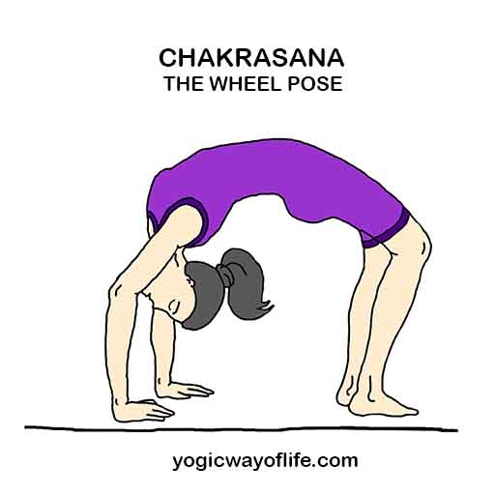

1. **Shavasan**

Shavasana is one of the vital practice of yoga, warming up and cooling of the muscles is very important in any exercise practice during workout. there are different yoga relaxation techniques to relax our body, breathing system, cardiac system, mind, etc. The yogic relaxation is very effective to relax compared to any other relaxation techniques because it will work on body and mind at the same time.

**Benefits:**

* Help to cool down our muscles and reduces body ache
* normalizes our breathing patterns
* relaxes heart by normalizing our heartbeat
* helps to get back energy, maintains energy level
* release mental tiredness and improves agility
* Maintain all the biological functions and chemical reactions properly for overall growth and health to grow.



**Steps of Shavasana:**

Scanning

Stability

Breathing

A-chant

U-chant

M-chant

A-U-M chant

OM chant

Other relaxation techniques

**IRT (Instant Relaxation Techniques)........ (Takes about one minute)**

Assume Shavasana and release all efforts, let your body free.

Stimulates the whole body by tightening it part by part from toes to crown holding breath inside.

Exhale and release.

At the end, feel the relaxation and blood flooding throughout the body.

Note: Heart patients and hypertension patients should do this gently without holding the breath for a

longer time.

**QRT (Quick relaxation techniques)..... (Takes about three minutes)**

Done in 5 steps.

Observe the abdominal movements - 5 times.

Synchronize breathing with abdominal movements -5 -times.

Deepen abdomen breathing by pushing a little when you inhale and sucking a little you exhale 2-3 times.

Breathe with feeling ; be aware of the contact points of the body with the mat and on the earth.

when you inhale imagine you are getting energy and lightness and when you exhale collapse and relax

your body as if the whole body is going into the ground - 5 times.

Now from the naval part chat “A” sounds and finish.

**DRT (Deep relaxation techniques)..... (Takes about 10 to 15 minutes)**

Gently move your whole body, make yourself comfortable and relax completely.

Bring your awareness to each and every part of the legs from toes to thighs and chant AAA.

Bring your awareness to each and every part of the middle part of the body and chant UUU.

Bring your awareness to each and every part of the head and chant MMM.

Observe whole body from toe to head and chant AUM.

Slowly come out of body consciousness and visualize your body lying on the ground completely collapsed.

Imagine the vast blue sky, expand awareness, become the blue sky, enjoy and feel the silence and

all - pervasive awareness.

Come back toi body consciousness and chant OM, feel the resonance.

Gently move your body and feel the lightness, alertness, energy and come up and finish.

**Pranayama**

**Guidelines to Practice:**

* Sit in a comfortable and stable posture with head, neck and back upright and adapt suitable mudra in your hands.
* Always practice pranayama on a non conductor yoga mat.
* No body movements and backbone movements during Pranayama practice.
* Feel the movements of the rib cage and diaphragm.
* Don't use fan while practicing Pranayama if you sweat.
* Keep your clothes loose and comfortable without more ornaments on your body.
* Practice in a clean and well-ventilated room or hall. If you are practicing in an open area, make sure there is no direct sunlight or blowing of cool area.
* Don’t suck breath or don't exhale forcefully. Try to enjoy every breath flow.
* Don't produce noise in nose during breathing in and out. If noise is coming in the throat like Ujjayi, noise is acceptable.
* Your breath flow must be like an oil flow, not water flow.
* Count your breath or repetition to progress day by day.
* You can do any number of rounds in Pranayama. It is strongly advised to start with lowest count. For example, five rounds or nine rounds.
* You increase your repetitions or rounds from practice , but don't decrease again.
* Make sure your mind is watching your breath flow actively with alertness.
* Yout breath is slower than your regular breathing.
* You can do different Pranayama on different days or many Pranayama at a stretch if time permits.
* You can use in any one mudra, akasha mudra, pruthvi mudra, vayu mudra, shourya mudra, apana mudra, apana vayu or haridaya mudra, prana mudra.

**Name of the Pranayamas**

1. Kapalabhati (Skill Shining Breath)

At first, for cleaning lungs and preparatory.

It is one of the shat-kriyas (6 detoxifications).

2. Vibhagiya Pranayama (Sectional Breathing)

Preparation to utilize full lungs and to increase lungs volume.

3. Bhastrika Pranayama (the Bellow’s Breath)

Heating Pranayama

4. Shitali, sheetkari andSadanti Pranayama are Cooling pranayamas.

5. Chandra (left) Anuloma Viloma and Surya (right) Anuloma Viloma Pranayama

Balances left and right nadis

6. Chandra Bhedana (intersect) Pranayama and Surya Bhedana pranayama

Balances left and right nadis.

7. Anuloma Viloma or Nadi Shodhana or Nadi Shuddhi Pranayama (Alternate Nostril Breathing)

Balance or equilibrium of body and mind and purification of nadis (72000).

8. Ujjayi Pranayama (The Ocean Breath)

Calming, soothing, relaxing, mental well being.

INHALE

THROUGH

BOTHE NOSTRILS

WITHCONTRICTED

GLOTTIS

9. Bhramari Pranayama (The Humming Breath)

Calming, Soothing, relaxing, Mental wellbeing.

**Sankalpa Ishtartha Sanjeevini Dhyana**

(Determination like eternal meditation)

1. Sit in your comfortable position facing north. Back straight Gyaana mudra lin both the hands

2. Visualise your parents, your favourite diely and Guru in live form. Apply vibuthi of Cowdung on your fourhead with little finger, ring finer and middle finger from right to left three times.

3. Apply shielding around you in triangle form by chanting “Om-hreem” parabramha shakthi( Add your name of your favourite diety, family diety with “Shiva Prachodayath”) After chanting blow out the air from your mouth as “uppppp.....” (3 times)

4. Chant “Om Shiva” beeja mantra in 3 pitches. Om Shiva (low) | Om shiva (medium) | Om shiva (High)\

Om Shiva (high)| Om shiva (medium) | Om shiva (low) Next chant Om shiva in mind and visnalise for sometimes.

12. With faith and trust link the divine connection with your parents, guru & favourite diety.

13. Close your eyes, visualise lord sanitur at your bach head, sunrays falling at 45o, visualise golden sunrise in your mind and pray mentally chanting below verses.

14. Om sapra ashwa rudram, nahshatra malaam| Chaaya lolam, chandra palaam, gangana sanchari, Bhaskaraya namaha||

15. Sent by air

16. Sent by poornia

17. Om tham mitraay namah

Om hreem Ravaye namah

Om hroom suryaya namah

Om namo bhagavathi suryaanarayana namah

Om sree savitra Surya Narayana namah

Om sarvadeva swaroopa Sri Ramakrishnaaya namah

18. Rhythmic clapping (few times)

Bhastrika

Kapalabhathi

Nadi shuddi pranayama

19. Be aware of your breathe

do deep breathing for 11 times

Visualise yourself filled with divine power

20. We have energy centre in our subtle body, which are reffered as chakras each chakra has one seed manthra, by chanting seed mantra, we can purify our gross body & subtle body. We develop harmony and balance in our body and mind. We can expenence happy and blisefulness whole day. while chanting seed mandtras. We have to focus on our energy centres with awareness.

21. Visualise silver line from mooladhara to sahashrara chakra.

22. Visualise colours, petals of all the chakras each at a time & chant beeja mantras 11 times

23. Before chanting at each chama, chant, “Kundaline Awakening” 3 times.

24. Deeply inhale & exhale completely 11 times whilel exhaling be aware of sound

25. Connect your tongue tothe palette and do deep breathing 11 times with “Sweekara” mudra

26. Chankt Om cara beeja mantra. follow the rules below

(1). Visulaise Brahma & Saraswathi in live form chant “AAA’ kara from the Navel. Be aware of navel.

(II) Visualise Vishnu & lakshmi in live form at heart chant “uuu” kara. Be aware of heart

(III) Visualise shiva & Parvathi in live form at our throat and sense organs. chant “mmm’kara . Be aware of all sense organs and throat.

(IV). Chant ‘Kara, ‘UUU’ kara, ‘mmm’ kara in one single breathe, visualise divine mother in the live form (durga, kali or chamundi). Be aware of your toes to tip of the head and chant ‘AUM’ kara

(V) Chant Om Kara - for one breathe

75% & UUU, 25% ‘MMM’

(VI) 50% AA & UU , 50% mmm

(VII) 25% AA & UU, 75% mmm

(VIII) 1% AA & UU, 99% mmm - for

(IX) 01 time Omkara - one breathe

(X) 02 times Om - one breathe

(XI) 03 times Om - one breathe

(XII) 04 times Om - one breathe

(XIV) 05 times Om - one breathe

(XV) 06 times Om - one breathe

(XVI) 07 times Om - one breathe

(XVII) 08 times Om - one breathe

(XVIII) 09 times Om - one breathe

(XIX) 10 times Om - one breathe

27. Chant 3 time Om kara, close your ears with thumb and silently the listen the vibration of chant

28. Now again visualise lord sun in front of you.

29. Meditate on Agra chakra visualising lord sun in between the eyebrow

30. Visualise yourself sitting in the pyramid Scan your body from toes to the tip of the head. Feel all the parts are strong and working properly.

31. Now adopt Sweekara Mudra in both hands. visualise your are receiving divine tight & devine power from the universe through the tips of the fingers & palms.

32. Affirm all the wishes are fulfilled in your subconscious mind, Affirm you are becoming better physically & mentally. I have reached my goal, I am achieving, progressing in all aspects of life, culturally, academically, financially, professional, spiritually, also in yoga field.

Visualise all the comforts and wishes are already fulfilled.

33. with the helo of divine power, increase your inner stength.

34. Visualise lord smys Agni kunda in front of your right knee, receiving inner strength, inner conciousness, brightness, power, happines, prosperity and all other good qualities.

35. Visualise all your negative qualities, lower emotions like disease, sadness, povirty, worry are going out to the Agni kind in front of left knee and disintegrating all the negative energies.

36. Visualise Rainbow in golden surya or sun, feel yourself in that golden light. Affirm you have all the things you wish, success, peace, confidence, happiness, health and prosperity.

37. Shield yourself and your parents, family, all the assets, vehicles & etc., shield will be in triangular shape.

38. Now being back your awareness to your body Adopt swekaara mandra in left hand and blessingmudra in right hand, close your eyes. (Students must sit facing each other in two lines with 2 feet distance between each other) mentally say let good happen with proper breathing eyes closed.

39. Say thanks to your parents, favourite diety, family diety and supreme god. for all the blessings to grow in your specified field.

40. Om sarvejana Sukhino Bhavanthu|

Sarve bhadrani paryanthu|

Maakaschith dukha bahavbhaneth

Om Shanthi Santhi Shanthihi.

41. Do not use this power for any bad things you have to pray even for your enemies pray for all living beings and other kingdoms of life. Be good, do good, wish good, sent positive vibration to all your friends, relatives and around you. Slowly you can see the changes in you, all the lower emotions will be distingrable.

42. Adopt namaskara mudra, thumb at Ajna chakra, chant ‘shiva Om’ three times. Breathe out, bending forward surrendering to mother earth. Inhale come up, rub your eyes both the palms place both palms on your eyes. with few blinks open your eyes with big smile & confidence.

Note: To achieve success in any field practice this meditation for 48 days (Don't miss for one day also)

**HAND MUDRAS**

# Apana Vayu Mudra – Hand Gesture for Apana Flow

Apana Vayu Mudra is a hand mudra or gesture used for improving health of the small and large intestine and related organs of elimination. In Ayurveda, the thumb represents the fire element, the middle finger indicates space element and the ring finger the earth element. Apana Vayu mudra brings together these three elements, which is said to give therapeutic benefits.

*Apana* Vayu is the second of the five Pranas and is primarily responsible for elimination. It controls organs situated between the naval and the perineum including, small and large intestine, kidneys, urinary system and reproductive systems. Elimination of waste as faeces, gas and urine is done by *Apana Vayu*. Also, ejaculation of sperm, Monthly menstrual cycle for women and expulsion of foetus during childbirth is done by *Apana Vayu*. *Apana Vayu* flows downwards and stimulates the downward movement of the wastes. Disturbances in *Apana Vayu*can cause constipation, diarrhoea, piles, etc.

*Apana Vayu Mudra* is aimed at improving the function of *Apana Vayu* and its associated organs and its physiology. It is easy to practice and can be practiced any time of the day.

### **Benefits of Apana Vayu Mudra**

1. Apana Vayu Mudra helps the small and large intestine and relieves constipation.
2. It is known to be good for heart ailments and can be used for those complaining of chest pain due to cardiac malfunction.
3. It can relieve indigestion.

**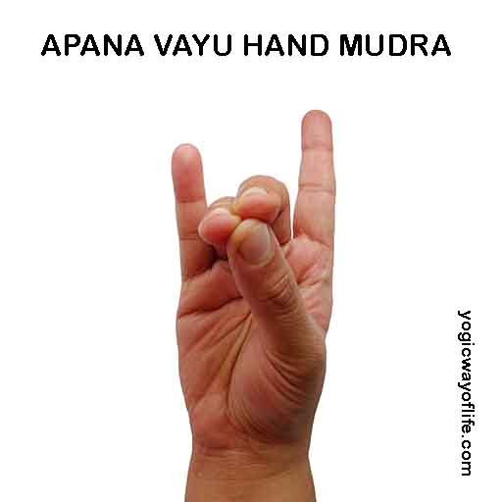**

# Jnana Mudra – The Gesture of Wisdom

Jnana Mudra or Gyan Mudra is the most common yogic mudra used in meditation. In Sanskrit, the word ‘Jnana’ means knowledge or wisdom and ‘mudra’ means sign or gesture. It literally means the psychic gesture of Knowledge or wisdom.

### **Benefits of Jnana Mudra**

        Jnana Mudra modifies the pranic flow in the fingers. Usually the prana flows out through the extremities (hands, feet, head, etc.). In Jnana mudra we redirect some the flow by joining the thumb and the forefinger, and forming a circular loop. This redirects the energy inwards so that the mind energy is internalized. It calms the mind. Meditative asanas make the body steady, while the mudras add to the steadiness the mind. Using this mudra one can sit in meditation for a long duration, as it reduces the distractions arising in the mind. One can look at Jnana mudra as psycho-neural finger lock which helps to internalize the prana.

**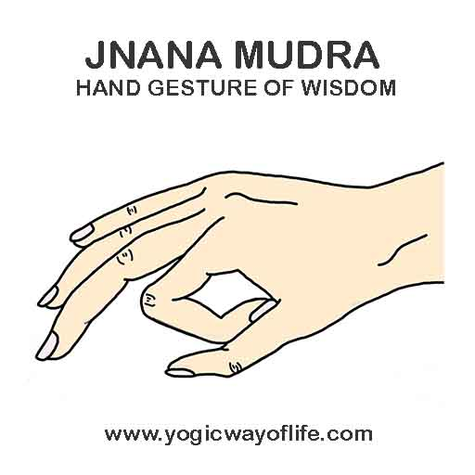**

# Prana Vayu Mudra – Hand Gesture for Prana Flow

Prana Vayu Mudra is a hand mudra or gesture used for improving vitality and immunity. In Ayurveda, the thumb represents the fire element, the little finger the water element and the ring finger the earth element. Prana Vayu mudra brings together these three elements, which is said to give therapeutic benefits.

*Prana Vayu* is the main energy among the *Pancha Prana* or the five Pranas. All organs of the thorax including heart and lungs are maintained by Prana Vayu. The basic function of respiration and pumping of heart is controlled by Prana Vayu.

*Prana Vayu Mudra* is aimed at improving the function of *Prana Vayu* and its associated organs and its physiology. It is easy to practice and can be practiced any time of the day.

### **Benefits of Prana Vayu Mudra**

1. Prana Vayu Mudra increases the Prana or vital energy, thereby energising your body.
2. It is good for chronic fatigue and debility.
3. It is good for the eyes and improves vision.
4. It improves functioning of the heart and lungs.
5. It improves self-confidence, releases mental stress and reduces irritability.
6. Prana Vayu Mudra improves blood circulation.
7. Prana Vayu Mudra is used in Ayurveda and in yoga therapy to improve body immunity and promote self-healing.
8. It can be used during recovery of any illness as we need an extra burst of energy to overcome our weakness.
9. It is said to help with any vitamin deficiencies.
10. Prana Vayu Mudra is also said to help with arthritis and reduces joint pain.

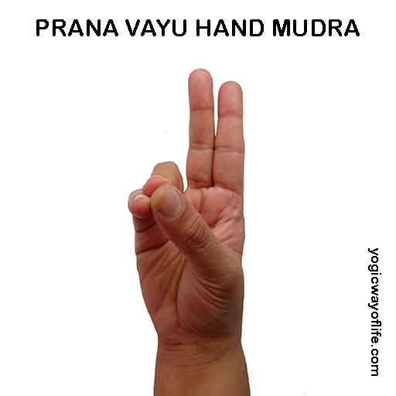

# Pushan Mudra – Hand mudra for Nourishment

Pushan Mudra is a yogic hand mudra or gesture used for improving digestion and nourishment. According to Ayurveda, the thumb represents the fire element, the index finger indicates the air element, the middle finger indicates space element and the ring finger, the earth element. In Pushan mudra, the hand gesture is different for the two hands. In the right hand use the [Apana Vayu mudra](http://www.yogicwayoflife.com/apana-vayu-mudra-hand-gesture-for-apana-flow/" \t "_blank) and for the left hand use the [Prana Vayu Mudra](http://www.yogicwayoflife.com/prana-vayu-mudra-hand-gesture-for-prana-flow/" \t "_blank). Together they form the Pushan Mudra.

Pushan is also one of the names of the Sun God. The Sun nourishes all the creatures living on earth. Pushan Mudra literally means the Mudra or gesture of Nourishment.

### **Benefits of Pushan Mudra**

1. Pushan Mudra improves the functioning of the digestive system.
2. It is good for liver, stomach and spleen.
3. Pushan mudra can be also done sitting in [Vajrasana](http://www.yogicwayoflife.com/vajrasana-the-thunderbolt-pose/" \t "_blank), immediately after meals to improve digestion and assimilation of digested food.
4. It can relieve nausea during motion sickness.
5. It helps to detoxify the body.

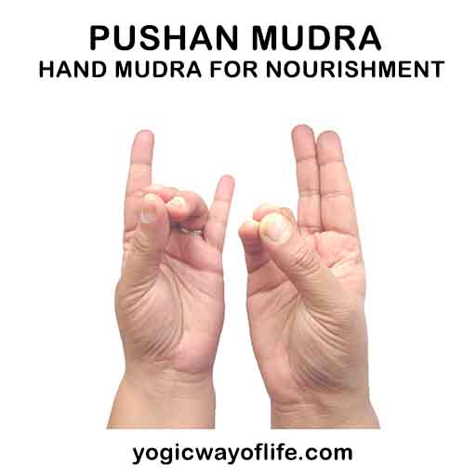

# Samana Vayu Mudra – Hand gesture for Samana Flow

Samana Vayu Mudra is a hand mudra or gesture in yoga, used for improving digestion and assimilation. In Ayurveda, the thumb represents the fire element, the middle finger indicates space element and the index finger, the air element, ring finger indicates earth element and the little finger indicates water element. Samana Vayu mudra brings together these five elements, which is said to give therapeutic benefits.

*Samana* Vayu is primarily responsible for digestion, absorption and assimilation of food. It functions at the navel region and responsible for working of the organs involved in digestion like stomach, liver, small intestine, pancreas, etc. Disturbances in *Samana Vayu*can cause problems with the digestive system.

*Samana Vayu Mudra* is aimed at improving the function of *Samana Vayu*. It balances all the energies in the body is also referred to as the ‘balancing air’. It is easy to practice and can be practiced any time of the day.

## ****Benefits of Samana Vayu Mudra****

1. Samana Vayu Mudra improves digestion.
2. It balances the metabolism.
3. It improves functioning of the liver.
4. Samana Vayu Mudra removes loss of appetite.
5. It balances the body energies and the Tri-Doshas (Vata, Pitta and Kapha) of the body.
6. Samana Vayu mudra strengthens the body from inside and gives confidence of mind.
7. It helps with all gastric troubles and hypertension.

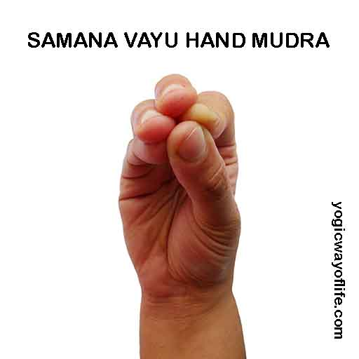

# Udana Vayu Mudra – Hand Gesture for Udana Flow

Udana Vayu Mudra is a hand mudra or gesture used for improving speech, respiratory system and the thyroid. In Ayurveda, the thumb represents the fire element, the middle finger indicates space element and the index finger, the air element and the ring finger indicates earth element. Udana Vayu mudra brings together these four elements, which is said to give therapeutic benefits.

*Udana* Vayu is primarily responsible for speech, functioning of the thyroid gland, blood supply to brain and thinking process. It functions from head to neck region and also on the respiratory system. Disturbances in *Udana Vayu*can cause problems with voice, shortness of breath, depression, memory loss, intellectual disability, etc.

*Udana Vayu Mudra* is aimed at improving the function of *Udana Vayu*. It is easy to practice and can be practiced any time of the day.

### **Benefits of Udana Vayu Mudra**

1. Udana Vayu Mudra helps to regulate the blood flow to the brain and helps in effortless thinking, creativity and intellectual sharpness. It can improve memory.
2. It improves the respiratory function and alleviate asthma by ensuring smooth breathing.
3. Udana Vayu Mudra improves voice and speech control.
4. It improves the functioning of thyroid and para thyroid glands.
5. Udana Vayu mudra can improve the strength of the limbs.

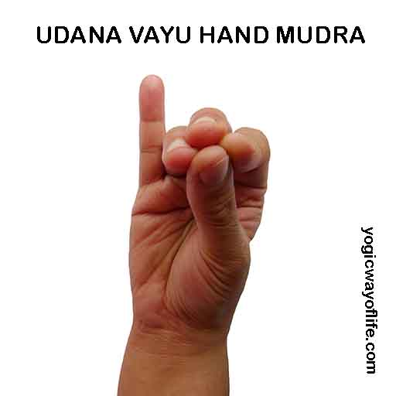

# Vayu Mudra – The air regulating yogic hand gesture

Vayu Mudra is a yogic hand mudra or gesture used for regulating the air element in the body. In Ayurveda, the thumb represents the fire element and the index finger indicates the air element. To do Vayu mudra, place the tip of index finger on the ball of the thumb and then place the thumb over the bent index finger firmly.

Vayu Mudra regulates the air element in the body. It relieves gas in the stomach, reduces body fat and improves digestion.

### **Benefits of  Vayu Mudra**

1. Vayu Mudra helps to relieve gas in the stomach and the intestines.
2. It helps to relieve arthritis.
3. Use this hand mudra for knee and other joint pains.
4. It is good for sciatica and neck pain.
5. It can calm the nerves and good for Parkinson’s disease and paralysis.
6. Vayu Mudra relieves all illnesses associated with Vata dosha according to Ayurveda, as it regulates the air element in the body.
7. It relieves pain in the spine and pain associated with cervical spondylitis.
8. Vayu mudra can be used, along with sitting in [Vajrasana](http://www.yogicwayoflife.com/vajrasana-the-thunderbolt-pose/" \t "_blank), immediately after meals to improve digestion and relieve gas.

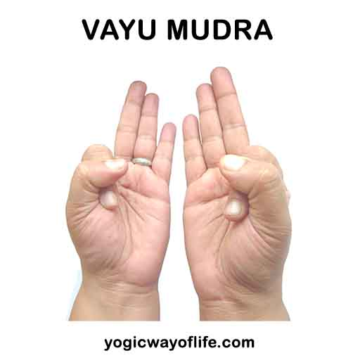

# Vyana Vayu Mudra – Hand Gesture for Vyana Flow

Vyana Vayu Mudra is a hand mudra or gesture used for improving blood circulation and regulating blood pressure. In Ayurveda, the thumb represents the fire element, the middle finger indicates space element and the index finger, the air element. Vyana Vayu mudra brings together these three elements, which is said to give therapeutic benefits.

*Vyana* Vayu is primarily responsible for circulation of blood in the entire body. It is responsible for distributing oxygen and nutrition to all the cells in the body through the circulatory system. Disturbances in *Vyana Vayu*can cause blood pressure problems.

*Vyana Vayu Mudra* is aimed at improving the function of *Vyana Vayu,* namely the blood circulation. It is easy to practice and can be practiced any time of the day.

### **Benefits of Vyana Vayu Mudra**

1. Vyana Vayu Mudra helps to regulate the blood circulation. High as well as low blood pressure can be balanced using this mudra.
2. It removes drowsiness and excessive sleep.
3. Vyana Vayu Mudra can give better control of response to temperature. Those who cannot tolerate excessive heat can benefit from this mudra.
4. It gives control over excessive thirst, sweating and urination.
5. Vyana Vayu mudra can be used to control diarrhoea.

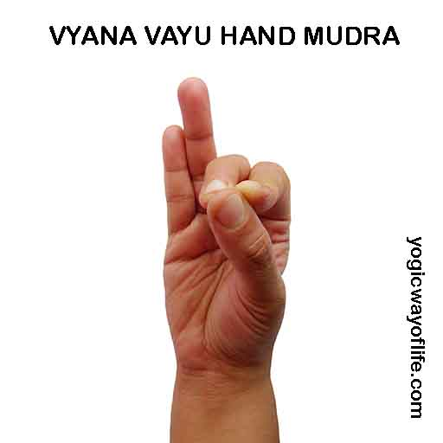

**BANDHAS**

Bandhas are neuromuscular locks that stimulate pranic flow when activated/

Perform in Padmasana or Vajrasana.

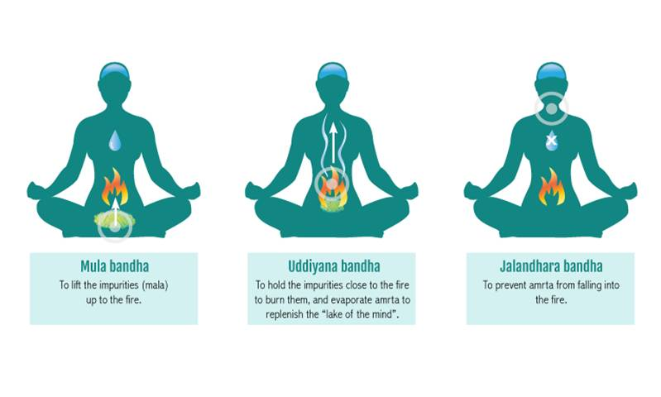

**1. Jalandhara Bandha**

Area between jaw and jugular notch. Extend your chin forward, then flex downwards and place in the notch between your clavicles.

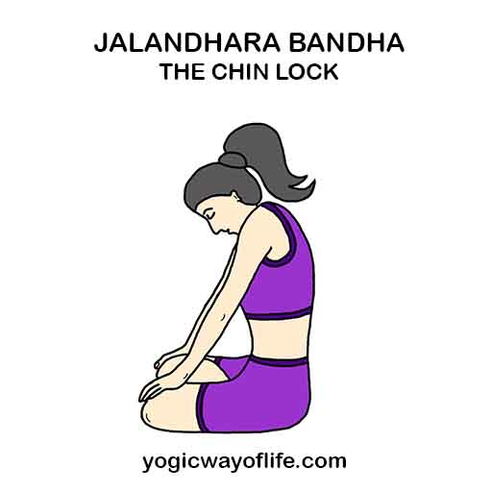

**2. Uddiyan Bandha**

Area above naval and below ribs. With an exhale draw diaphragm/upper abdominal region upwards into your rib cage.

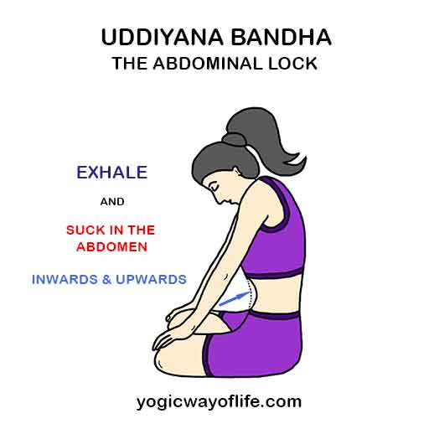

**3. Moola Bandha**

Area below naval and above anus. Contract muscles to draw your perineum upwards.



